1. Project Overview
Overview
The Electronics Supply Chain Analytics project aims to analyze transactional and operational data to evaluate the overall performance of an electronics supply chain. The project applies data analysis techniques to transform raw operational data into meaningful insights that support better business decision-making across multiple functional areas.
The dataset contains information related to customer orders, products, inventory, suppliers, shipping operations, sales performance, and customer experience. By analyzing these interconnected components, the project provides a comprehensive understanding of supply chain operations and identifies key performance indicators that influence business efficiency and profitability.
The analytical process follows a structured workflow, beginning with data loading, exploration, cleaning, and validation, followed by exploratory data analysis (EDA). Business metrics are then calculated and organized into domain-specific analyses to evaluate commercial performance, inventory management, supplier efficiency, and customer satisfaction.

Project Objectives
The primary objectives of this project are to:
- Analyze the overall commercial performance of the business.
- Evaluate revenue, profit, and profitability across different business dimensions.
- Monitor inventory availability and identify potential stock-related risks.
- Assess supplier performance based on reliability, quality, and production metrics.
- Analyze customer purchasing behavior and satisfaction.
- Evaluate shipping efficiency and delivery performance.
- Identify operational patterns and business trends using exploratory data analysis.
- Generate data-driven insights that support operational improvements and strategic decision-making.

Project Workflow
The project follows the standard data analysis lifecycle:
- Data Collection
- Data Understanding
- Data Cleaning & Preprocessing
- Data Validation
- Exploratory Data Analysis (EDA)
- Domain-Based Business Analysis
  - Commercial Insights
  - Customer Experience Analysis
  - Supplier Performance Analysis
  - Inventory Analysis
  - Shipping & Delivery Analysis

Expected Outcomes
By the end of this project, the analysis provides:
- A cleaned and validated dataset suitable for analysis.
- Business performance indicators across multiple operational domains.
- Aggregated analytical results for each business area.
- Actionable insights that highlight strengths, weaknesses, and opportunities for improving supply chain performance.

2. Dataset Description
2.1 Dataset Overview
The dataset used in this project represents the operational activities of an electronics supply chain. It contains transactional records that capture various aspects of customer orders, product information, inventory status, supplier performance, shipping operations, sales activities, and customer experience. Each record corresponds to a single customer order and provides detailed information that enables comprehensive business analysis across multiple operational domains.
The dataset consists of 32 features (columns) & 1500 row describing different business entities and performance indicators. These features include order details, product specifications, pricing information, discounts, sales performance, supplier quality metrics, inventory management, logistics operations, customer demographics, and return information. Together, these attributes provide a comprehensive view of the end-to-end supply chain process and support data-driven decision-making.
To facilitate better understanding of the dataset, the following table provides a description of each feature, including its data type and business meaning.
To facilitate a better understanding of the dataset, The following table presents a detailed description of all dataset features, including their data types and business definitions.
Column Name | Data Type | Description
Order ID | Categorical | Unique identifier assigned to each customer order.
Order Date | Date | Date when the customer placed the order.
Ship Date | Date | Date when the order was shipped from the warehouse.
Delivery Date | Date | Date when the order was successfully delivered to the customer.
Product type | Categorical | Category of the product ordered (e.g., smartphones, laptops, tablets).
SKU | Categorical | Stock Keeping Unit (SKU) used to uniquely identify each product.
Category | Categorical | Product pricing segment or classification (e.g., budget, mid-range, premium).
Price | Numerical | Selling price of a single product unit before applying discounts.
Discount (%) | Numerical | Percentage discount applied to the product price.
Number of products sold | Numerical | Total quantity of products sold in the order.
Units Returned | Numerical | Number of units returned by the customer.
Return Reason | Categorical | Reason provided for returning the product.
Revenue generated | Numerical | Total revenue generated from the order after applying the discount.
Profit | Numerical | Net profit earned from the order.
Customer Satisfaction Score | Numerical | Customer satisfaction rating for the completed order.
Customer demographics | Categorical | Customer demographic group associated with the order.
Sales Channel | Categorical | Sales channel through which the order was placed (e.g., online, retail, wholesale).
Payment Method | Categorical | Payment method used to complete the purchase.
Region | Categorical | Geographic region where the order was placed or delivered.
Stock levels | Numerical | Available inventory quantity for the product at the time of the order.
Reorder Point | Numerical | Inventory threshold at which replenishment should be initiated.
Stockout Risk | Categorical | Indicates the likelihood of inventory shortage for the product.
Lead time | Numerical | Number of days required to replenish inventory from the supplier.
Shipping times | Numerical | Total number of days taken to ship the order.
Shipping costs | Numerical | Cost incurred for shipping the order.
On-Time Delivery | Categorical | Indicates whether the order was delivered on time (Yes/No).
Supplier name | Categorical | Name of the supplier responsible for providing the product.
Supplier Reliability Score | Numerical | Performance score representing the supplier's reliability.
Manufacturing costs | Numerical | Total manufacturing cost associated with the product.
Quality Score | Numerical | Quality evaluation score assigned to the product or supplier.
Defect rates | Numerical | Percentage of defective products associated with the supplier or product.
Production volumes | Numerical | Total number of units produced during the production cycle.

Summary
The dataset combines transactional, operational, and customer-related information into a single integrated data source. These features collectively support comprehensive analyses of sales performance, inventory management, supplier efficiency, logistics operations, and customer behavior. Understanding the purpose of each feature is essential before proceeding with data exploration, preprocessing, and analytical modeling.

3. Data Analysis Workflow
Python Data Analysis Workflow
The data analysis process followed a structured workflow to ensure that the dataset was properly prepared before extracting business insights. The workflow began by loading the dataset into Python, followed by understanding its structure through exploratory inspection. Data preprocessing and cleaning techniques were then applied to improve data quality and remove inconsistencies. After validating the cleaned dataset, exploratory data analysis (EDA) was conducted to calculate key business metrics and generate analytical outputs for each business domain.
The workflow consisted of the following stages:
- Data Collection and Import
- Data Understanding
- Data Cleaning & Preprocessing
- Data Validation
- Exploratory Data Analysis (EDA)
- Domain-Based Business Analysis

4. Data Collection and Import
The required Python libraries were imported, and the dataset was loaded into a pandas DataFrame using pd.read_csv(). An initial preview of the dataset was then displayed using df.head() to verify that the data had been loaded correctly and to inspect the first few records.
Output:
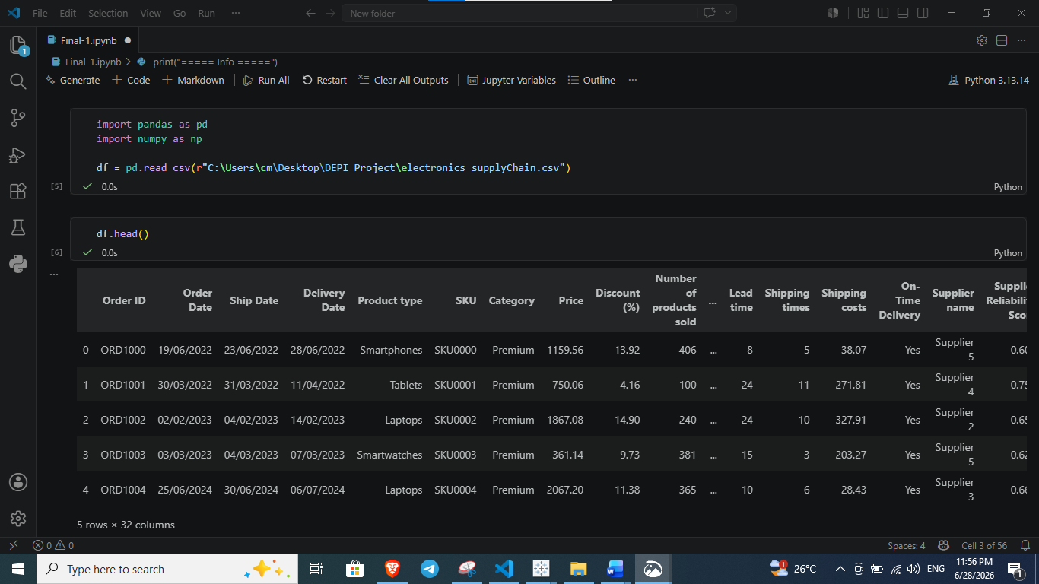
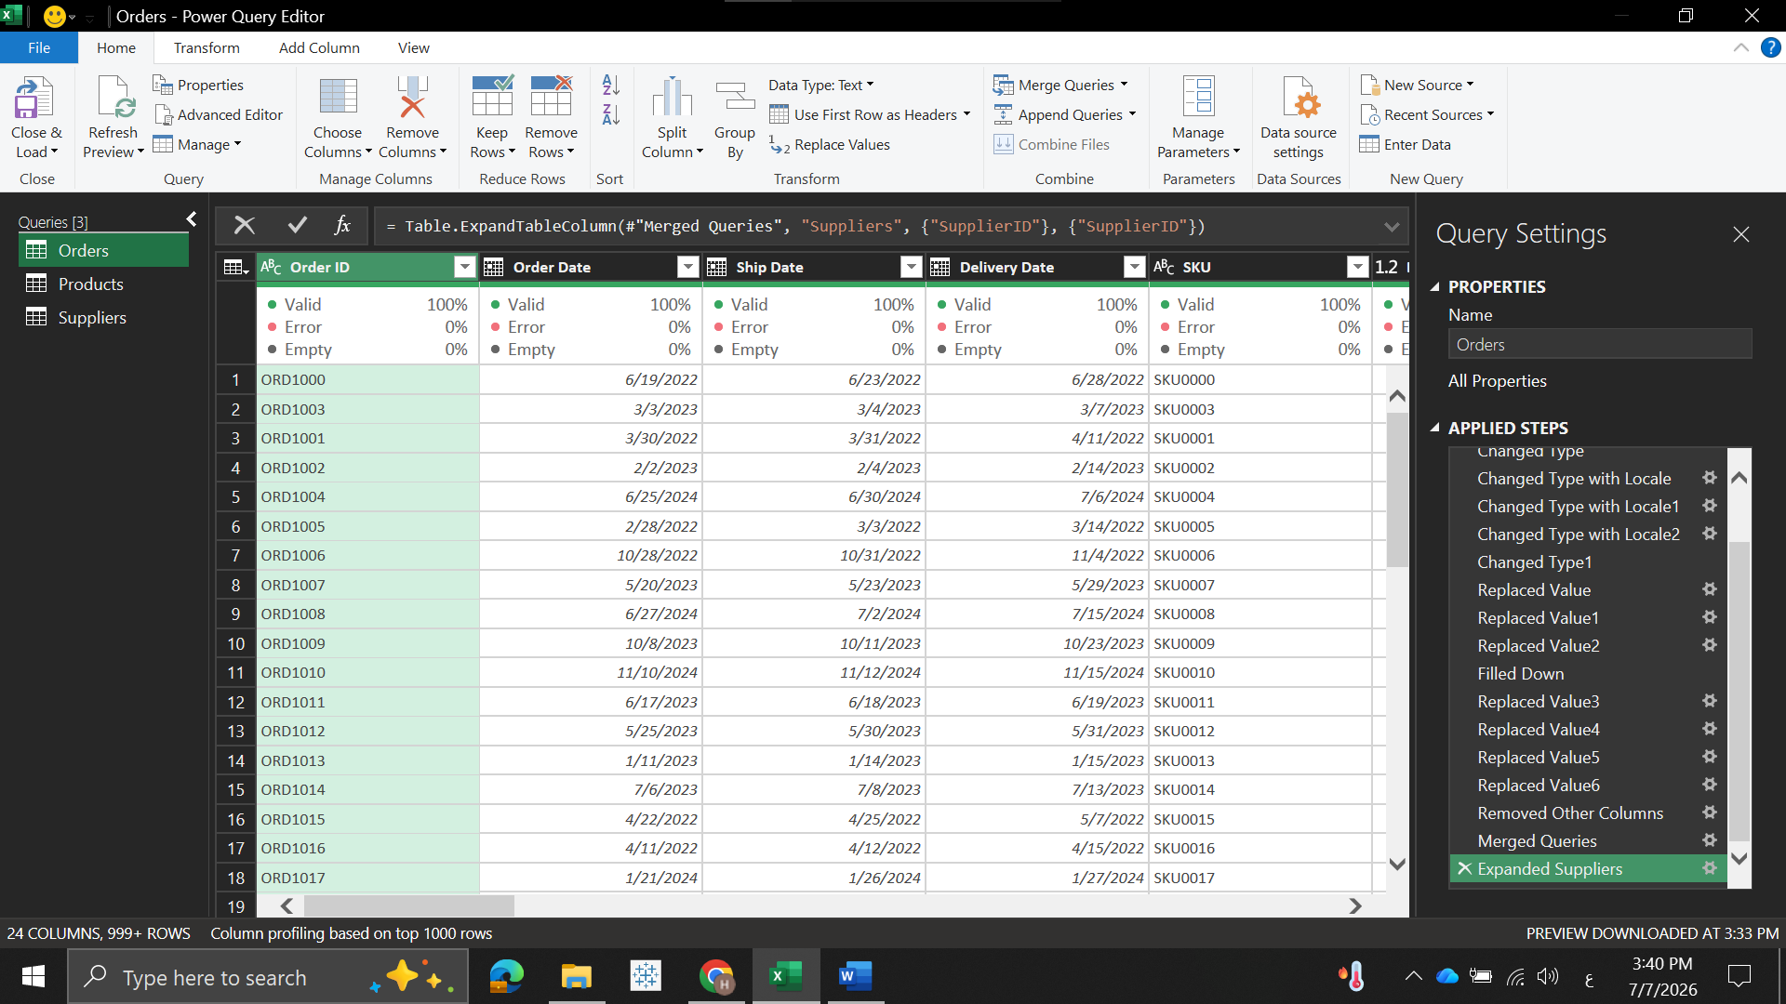
Observation:
The dataset was successfully loaded and contains the expected columns representing order information, products, pricing, inventory, suppliers, shipping, and customer-related attributes.
- The dataset was successfully loaded into a pandas DataFrame and Power query.
- The dataset contains transactional records, where each record represents a customer order.
- The available attributes provide comprehensive information that supports subsequent data cleaning, validation, and exploratory data analysis.
- The initial preview confirmed that the dataset structure aligns with the project requirements and is ready for the next stage of analysis.

5. Data Understanding (Initial Data Exploration)
5.1 Dataset Structure
Before applying any preprocessing techniques, an initial exploration of the dataset was conducted to understand its structure, assess data quality, and identify potential issues that could affect the analysis. This stage included examining the dataset structure, generating descriptive statistics, checking for missing values, evaluating feature uniqueness, and detecting duplicate records.
To better understand the dataset, its structure was inspected using the info() function. This step was performed to identify the number of records, available features, data types, and any missing values before starting the preprocessing phase.
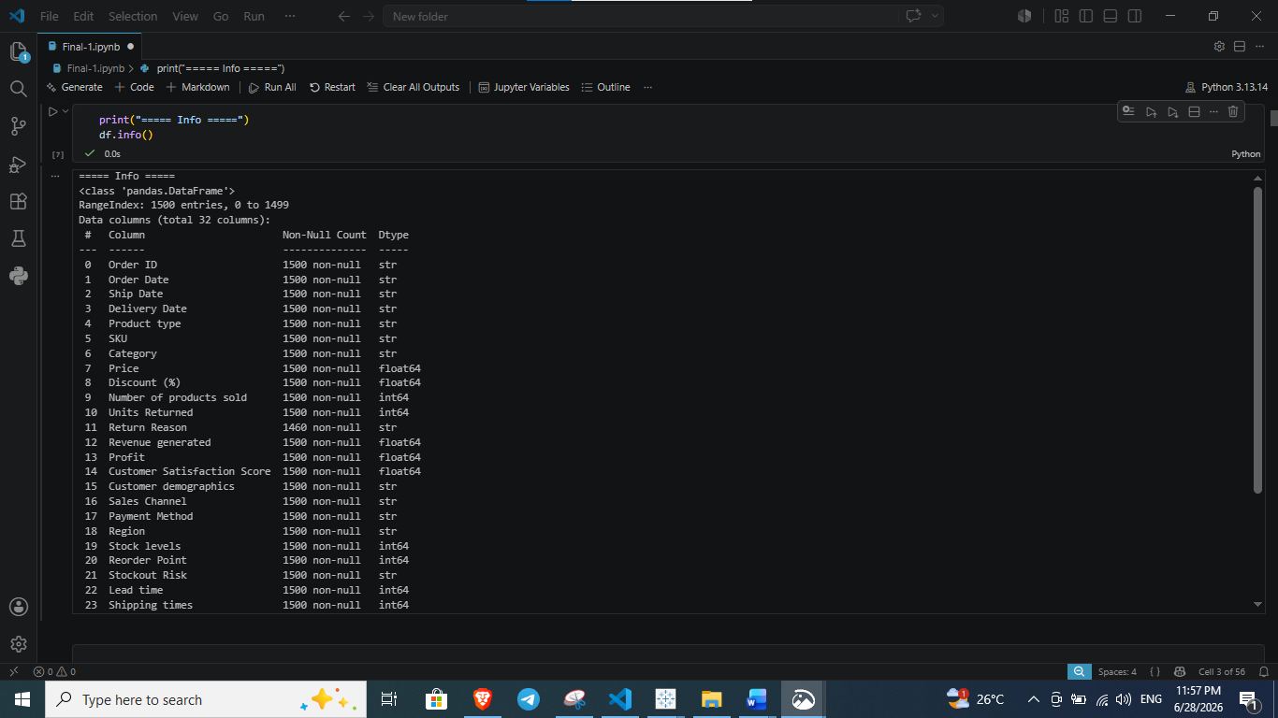
The dataset contains 1,500 records and 32 features. The output also shows the data type of each feature, including categorical (object), numerical (int64 and float64), and date-related columns (which will be converted during preprocessing). Additionally, the Return Reason column contains 40 missing values, indicating that some orders did not have a recorded return reason. This observation will be addressed during the data cleaning stage.
5.2 Descriptive Statistics
Descriptive statistics were generated using the describe() function to summarize the numerical features and understand their overall distribution before preprocessing.
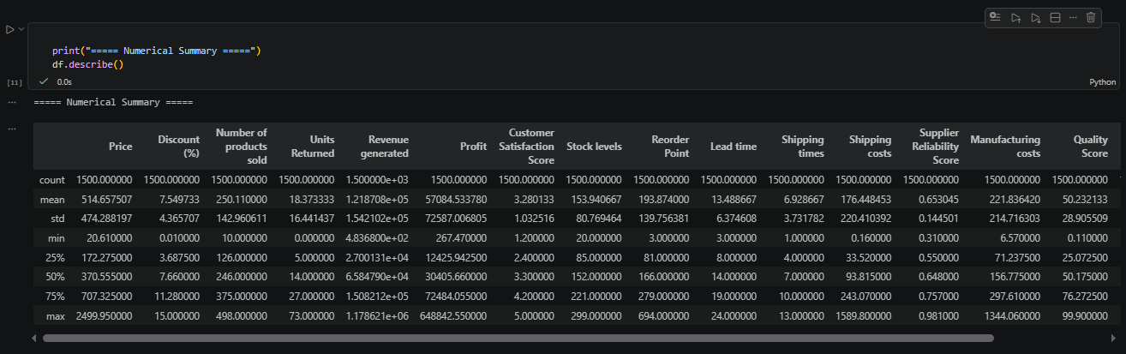
The statistical summary provides key descriptive measures such as count, mean, standard deviation, minimum, maximum, and quartiles for all numerical attributes. These statistics provide an initial understanding of the data distribution and help identify potential anomalies or outliers that may require further investigation during the preprocessing stage.
5.3 Missing Values Analysis
The dataset was examined for missing values to identify incomplete records and determine whether any data cleaning procedures would be required.
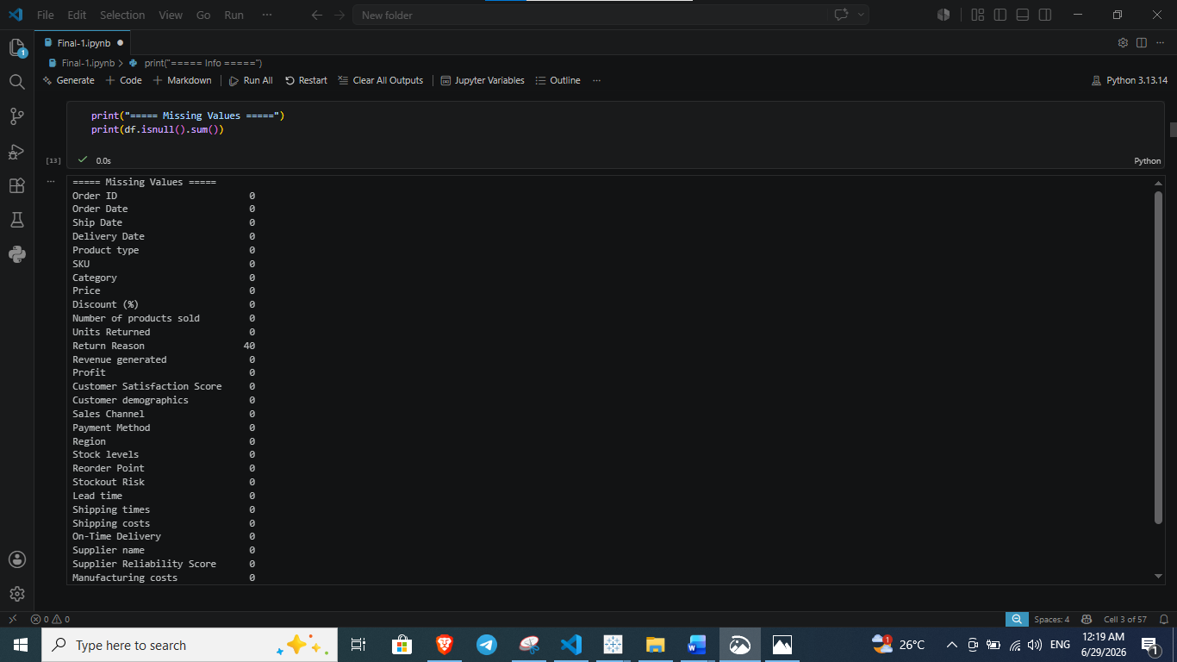
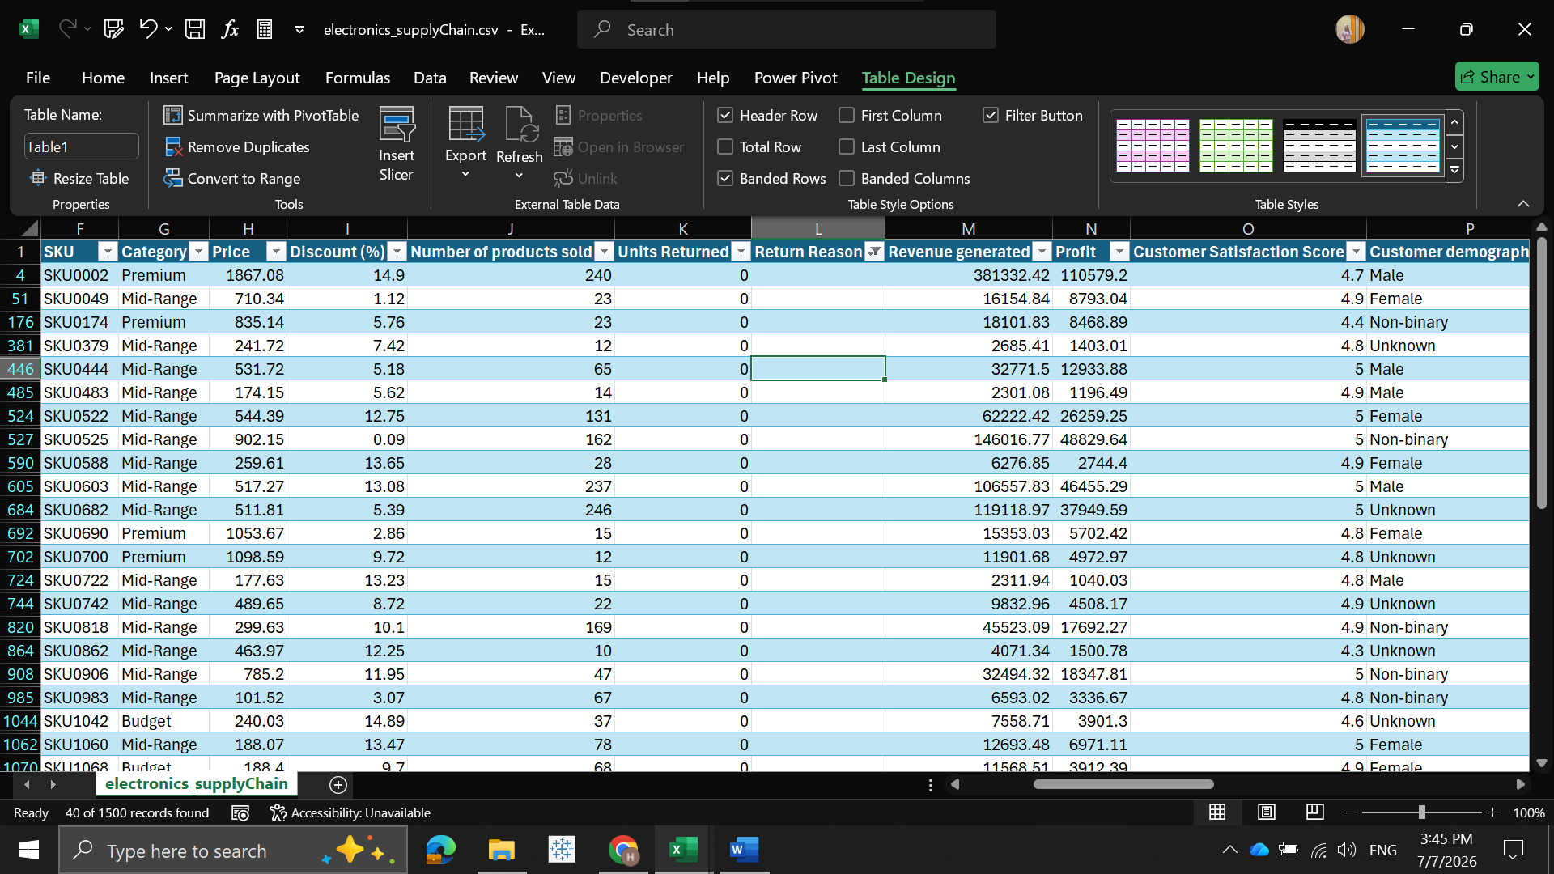
The results indicate that all features are complete except the Return Reason column, which contains 40 missing values. This is expected because not all customer orders resulted in product returns. These missing values were handled during the data cleaning stage to ensure data consistency.
5.4 Duplicate Records Analysis
Duplicate records were checked to verify the integrity of the dataset and ensure that each order is represented only once.
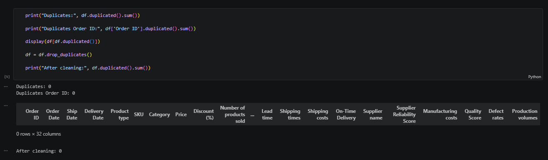
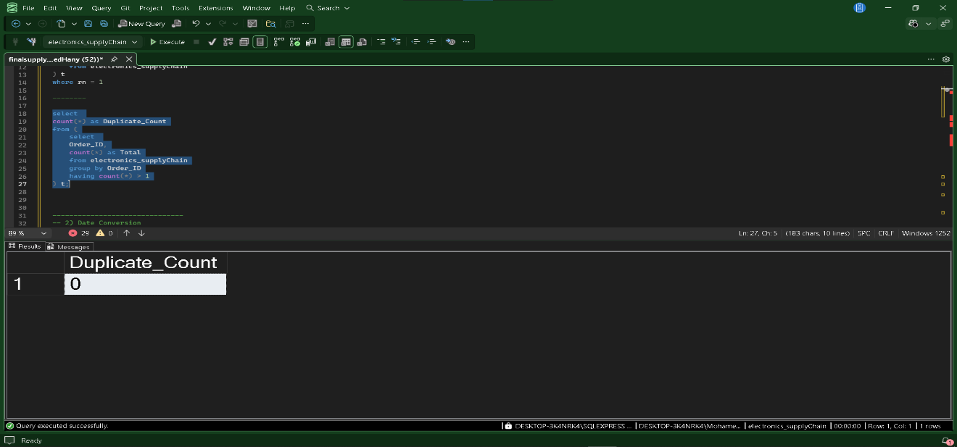
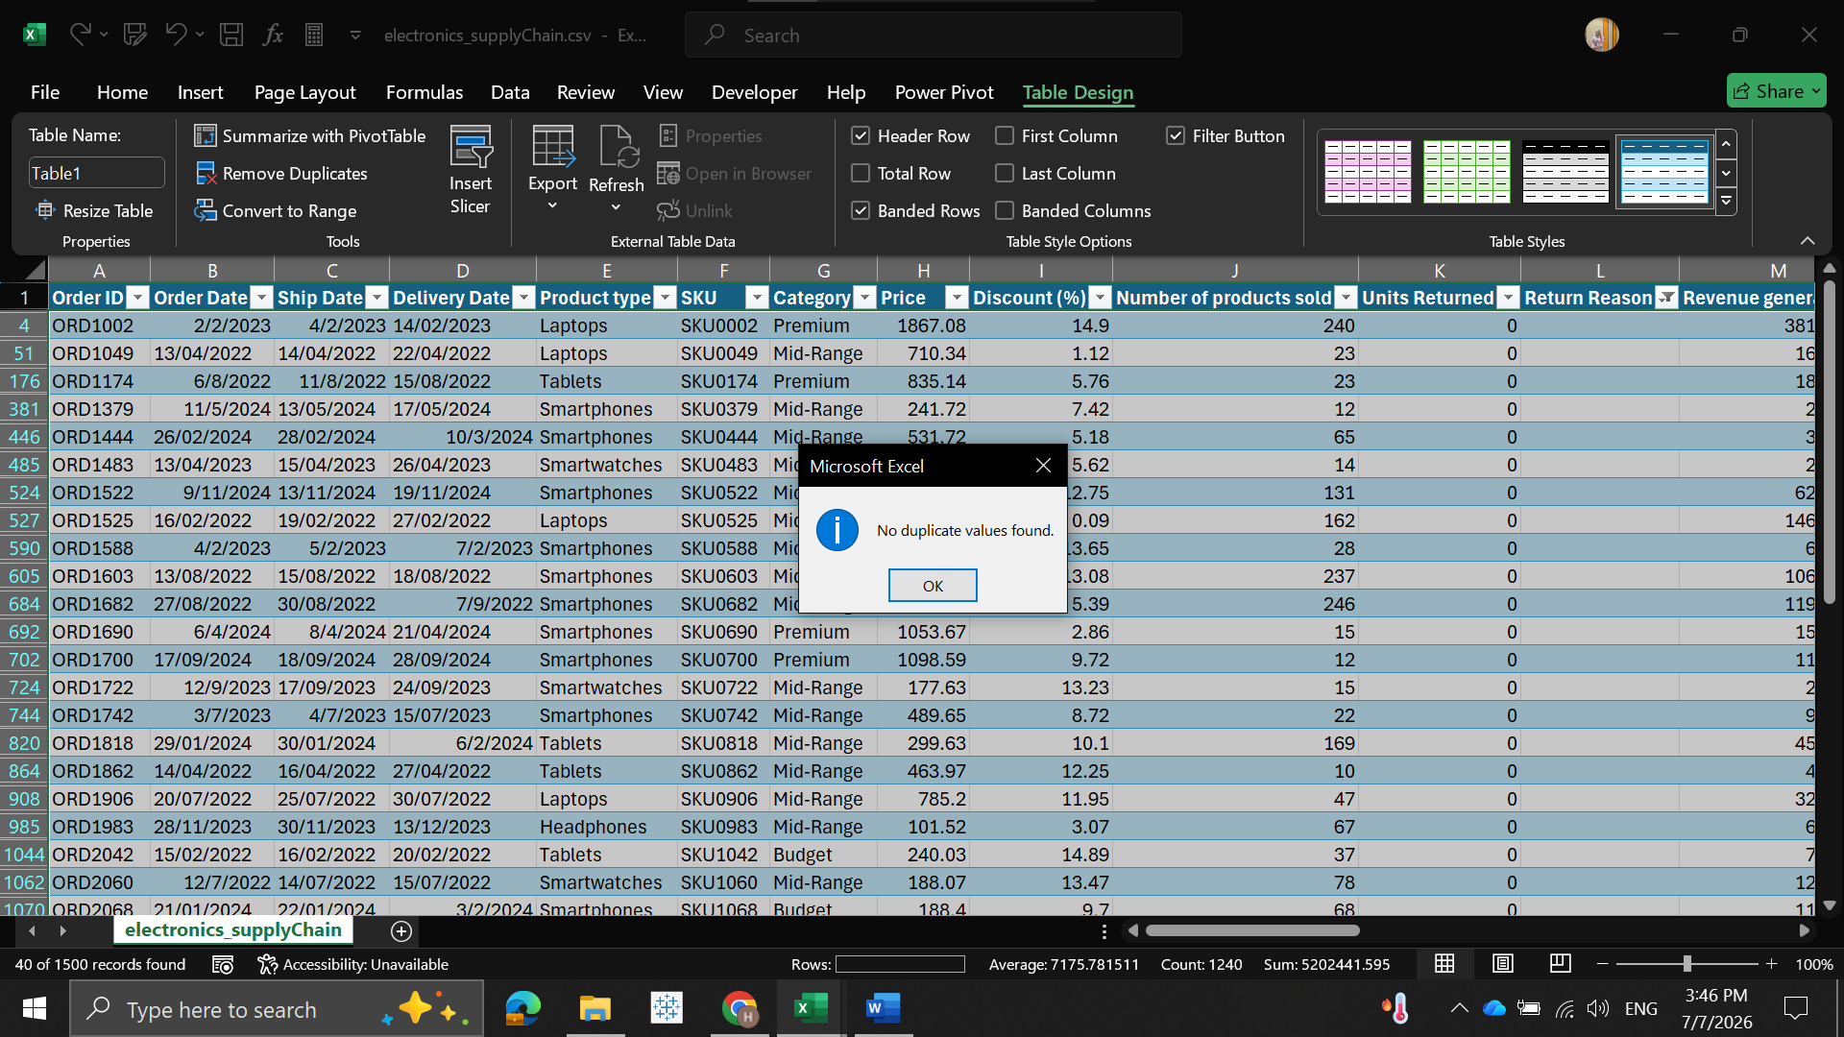

The duplicate analysis confirmed that the dataset contains no duplicate records and that all Order IDs are unique. As a result, no records were removed during this step, and the dataset maintained its original size.

6. Data Cleaning & Preprocessing
After exploring the dataset and identifying potential data quality issues, several preprocessing techniques were applied to improve data consistency, standardize the data format, and prepare the dataset for reliable analysis.
6.1 Date Processing and Validation
The date columns were converted into the datetime format to enable time-based analysis. Logical validation was also performed to ensure that each order followed the correct chronological sequence.

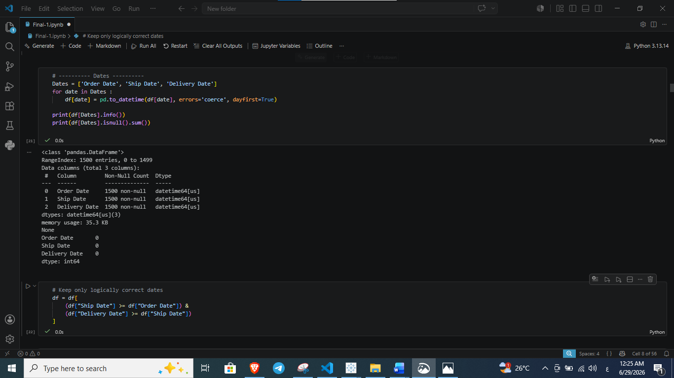
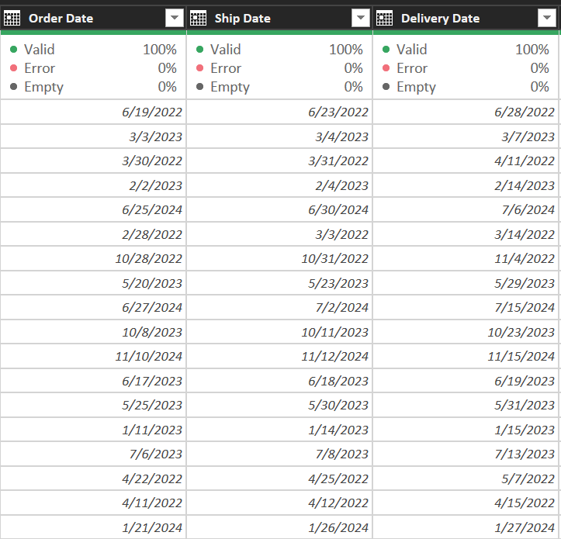
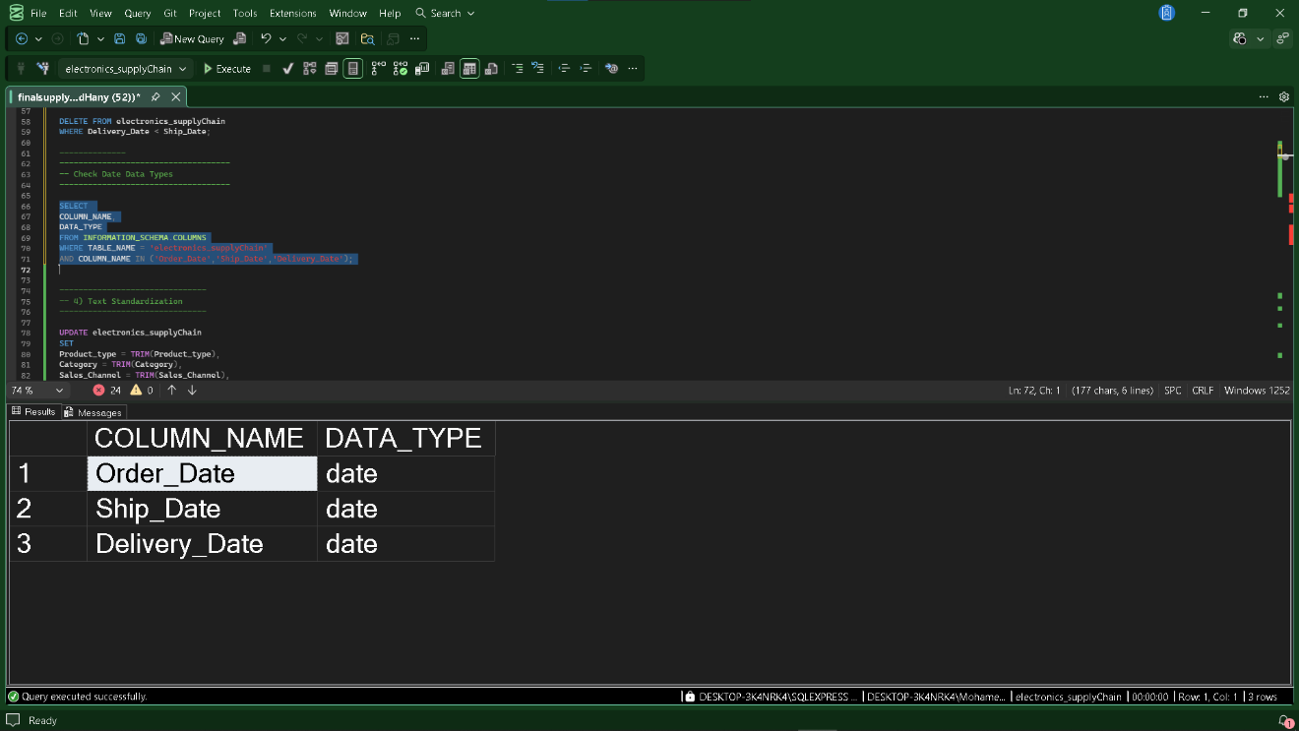

6.2 Data Standardization and Missing Value Handling
Categorical attributes were standardized to eliminate inconsistencies caused by different text formats. Missing values in the Return Reason column were also handled to maintain data completeness.
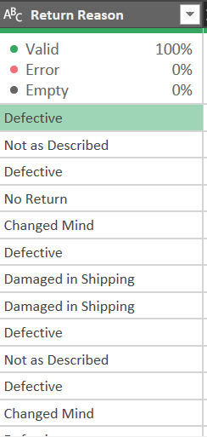
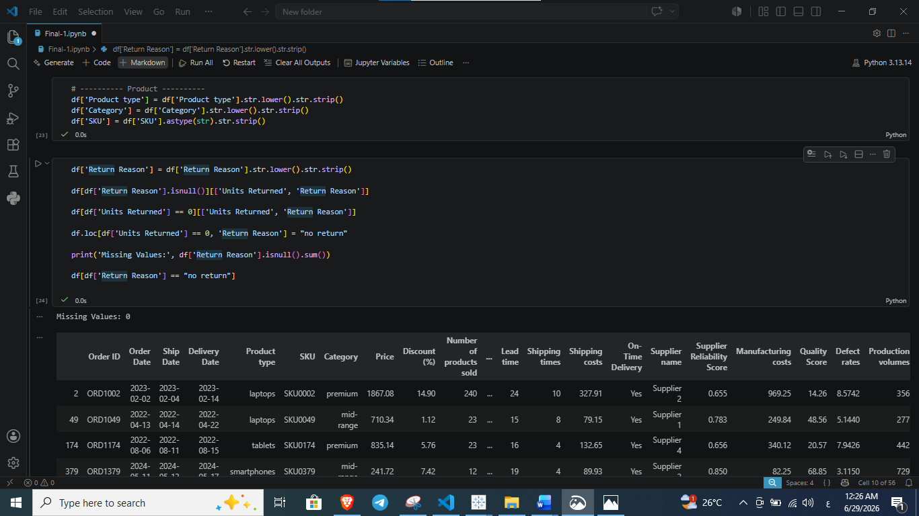

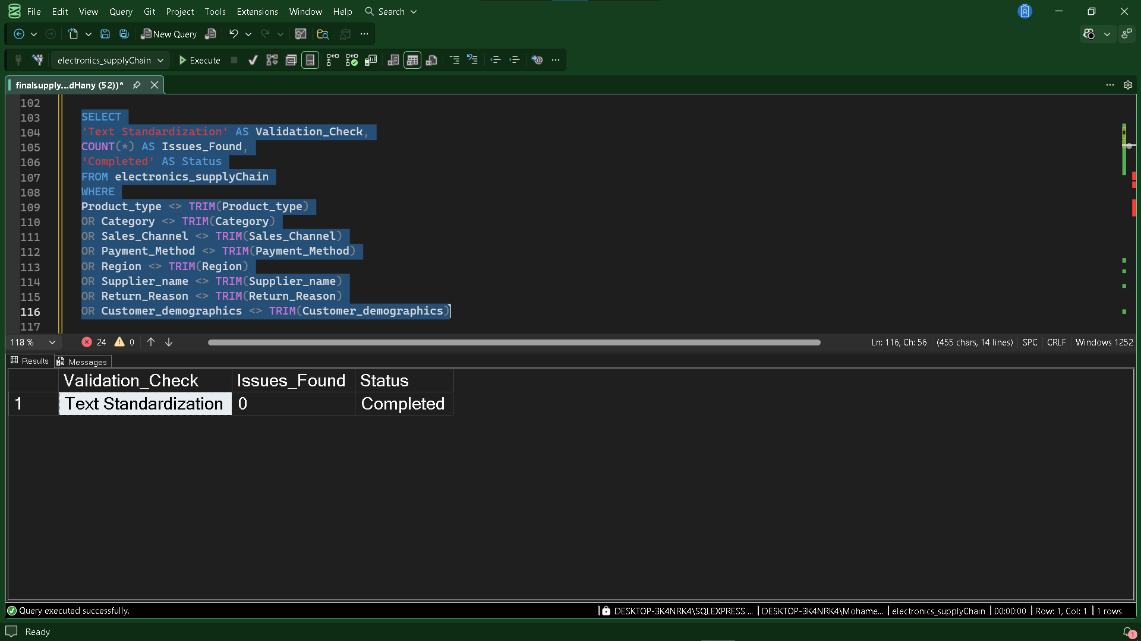
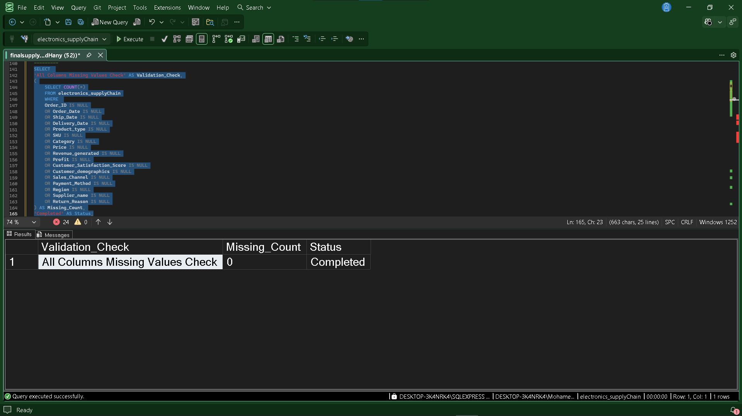
Observation
Text-based attributes were standardized by converting all values to lowercase and removing unnecessary spaces. Since orders with zero returned units do not require a return reason, missing values in the Return Reason column were replaced with "no return", resulting in a complete and consistent categorical feature. Customer and supplier-related categorical fields were also standardized to improve data quality before analysis.
6.3 Removing Invalid Records
The dataset was filtered to remove records containing invalid or logically inconsistent values that could negatively affect the analytical results.
Observation
Several validation rules were applied to retain only valid observations. These rules ensured that shipping times and prices were non-negative, discount percentages fell within the valid range, the number of products sold was greater than zero, and returned units did not exceed the quantity sold. Applying these rules improved the overall reliability of the dataset.
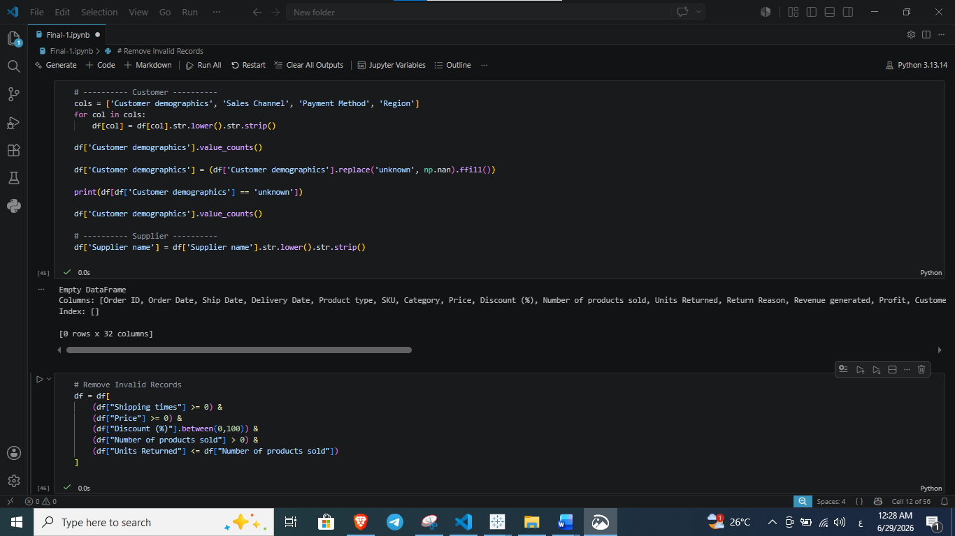
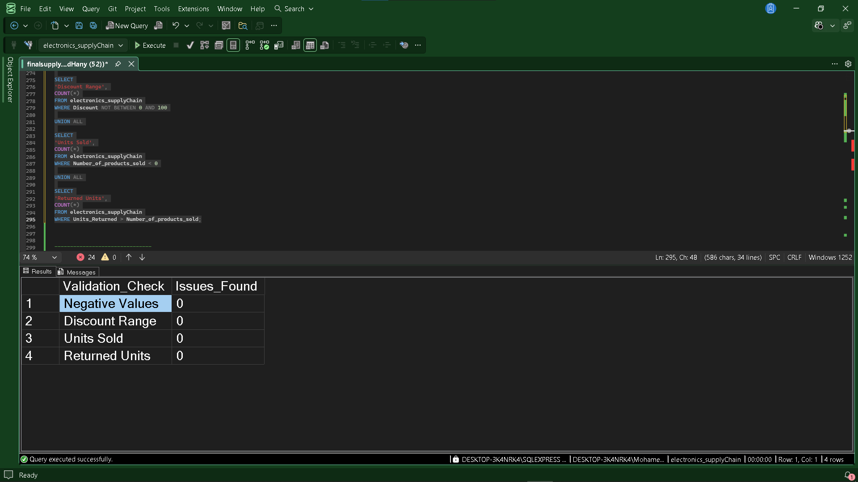
6.4 Final Data Validation
A final validation step was performed to verify the quality of the cleaned dataset before beginning the analytical phase.
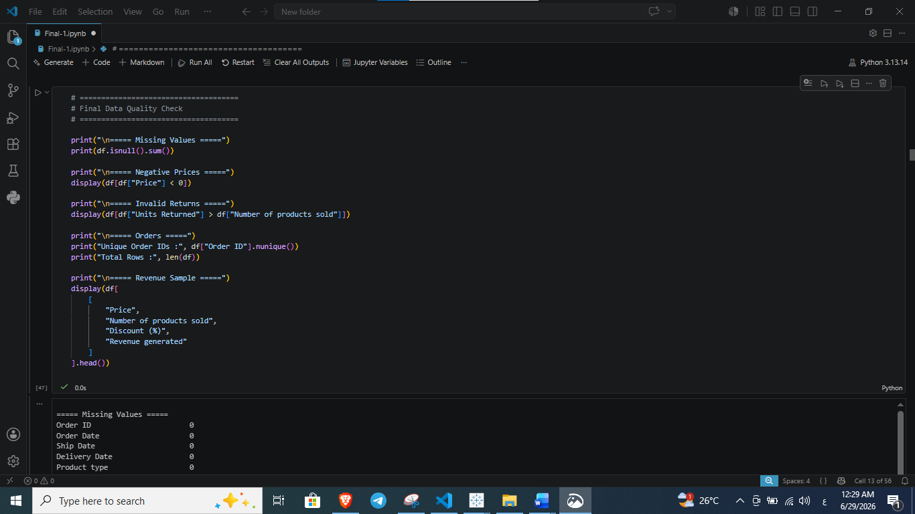
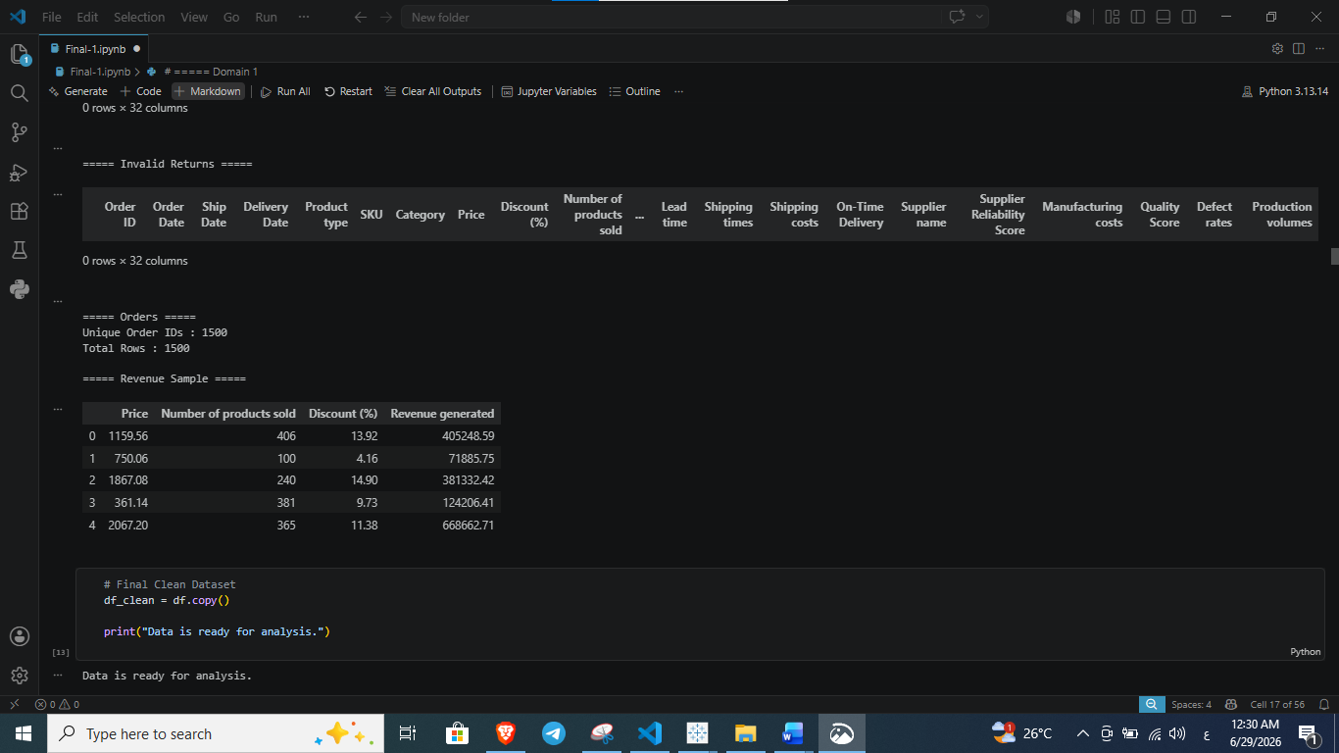
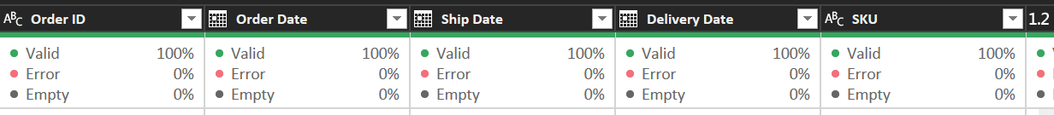
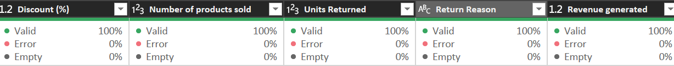
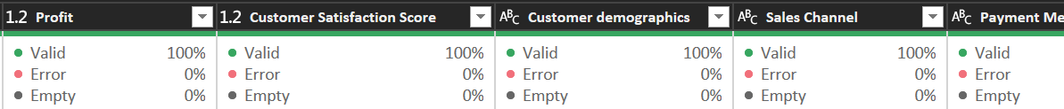
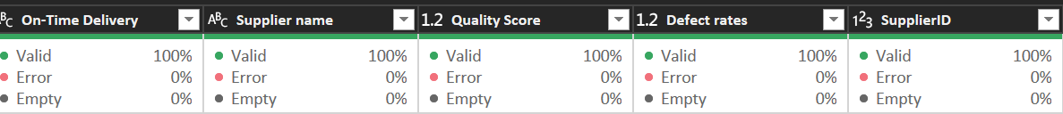
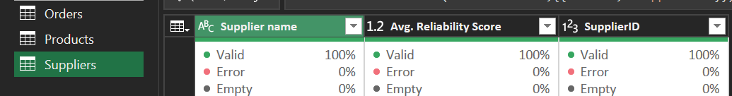
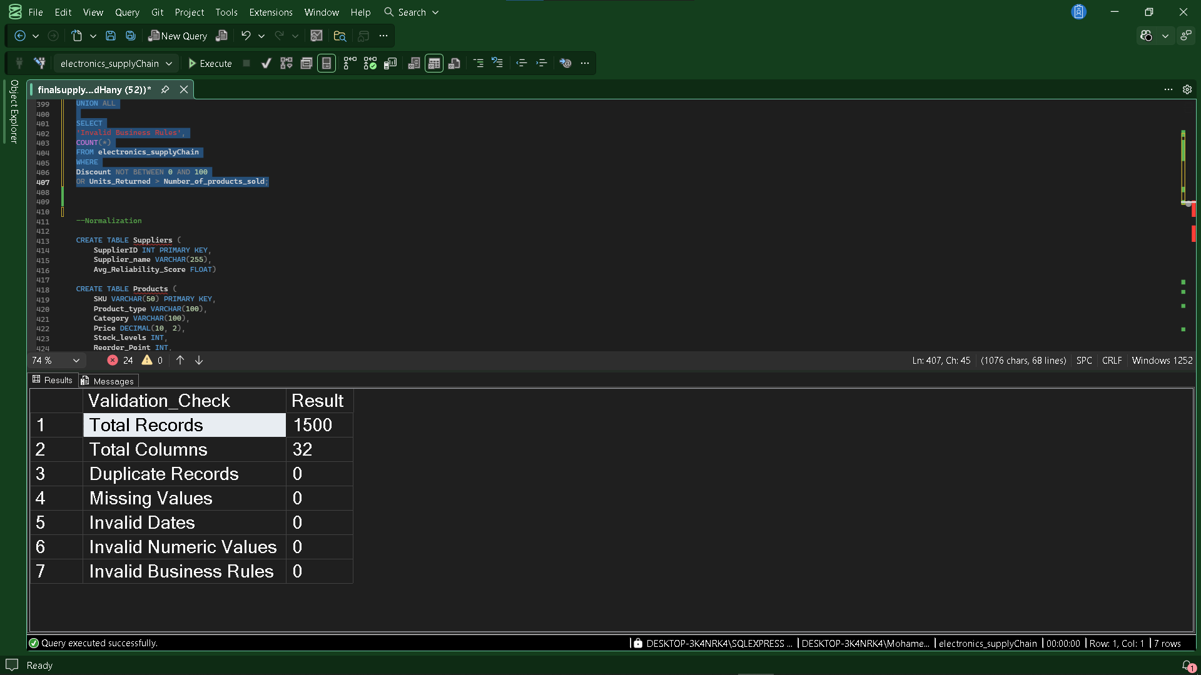

Observation
The final validation confirmed that the cleaned dataset contained no missing values in the required fields, no invalid prices, and no inconsistent return records. In addition, all order identifiers remained unique, and the cleaned dataset was copied into a new DataFrame (df_clean) to preserve a validated version for the exploratory data analysis stage.
Summary of Data Preprocessing
Step | Status
Duplicate Records Removed | ✅ Completed
Date Conversion | ✅ Completed
Date Validation | ✅ Completed
Text Standardization | ✅ Completed
Missing Value Handling | ✅ Completed
Invalid Records Removal | ✅ Completed
Final Data Validation | ✅ Completed
Analysis Dataset Created (df_clean) | ✅ Completed

Data Normalization
Following the initial data cleaning and validation phases, Data Normalization was implemented as a critical step to ensure analytical integrity and equitable comparison. This process aims to rescale numeric data into a unified range, preventing variables with larger magnitudes from disproportionately influencing the analytical models. This is particularly essential when integrating diverse performance indicators such as manufacturing costs, quality scores, and defect rates found within the database schema
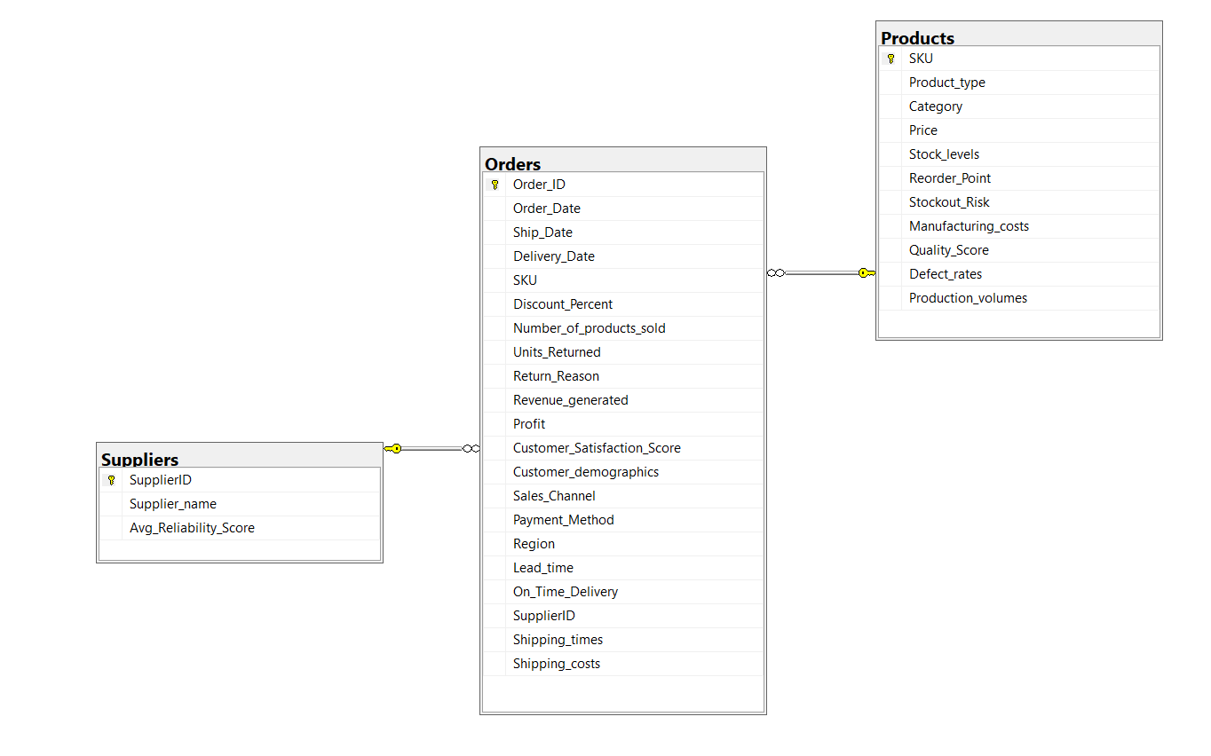
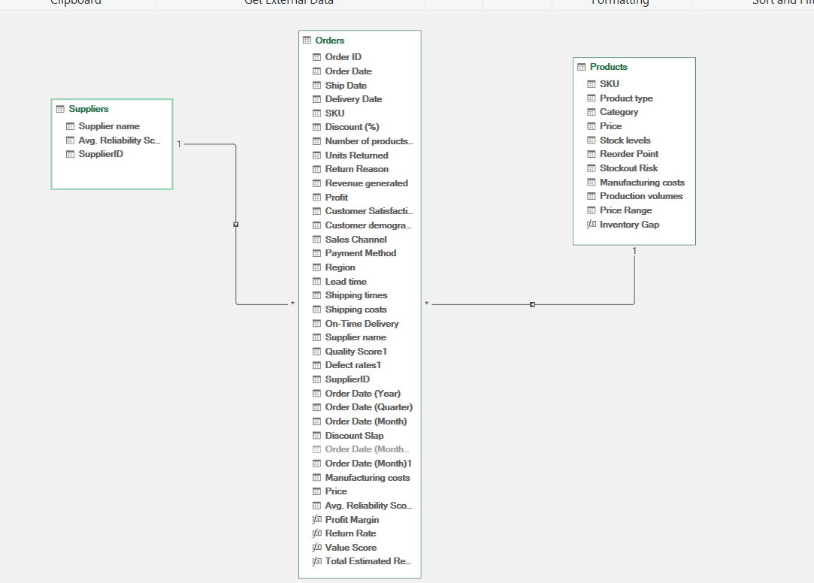
The schema highlights the structured relationship between the Suppliers, Orders, and Products entities. The normalization process applied to this dataset achieved the following:
Standardization of Metrics: By rescaling numeric attributes across the tables—specifically within the ⁠Products⁠ and ⁠Suppliers⁠ entities—we ensured that variables with different units of measurement are comparable.
Enhanced Analytical Precision: Normalization mitigated the impact of scale disparities (e.g., between ⁠Manufacturing_costs⁠ and ⁠Quality_Score⁠), allowing for a more accurate evaluation of supplier performance.
Foundation for EDA: This step served as the essential prerequisite for the Exploratory Data Analysis (EDA) stage, ensuring that the aggregated data used to derive Key Performance Indicators (KPIs) remains robust, reliable, and ready for advanced business insights.

7. Exploratory Data Analysis (EDA)
Overview
After completing the data cleaning and validation processes, the cleaned dataset (df_clean) was used to perform Exploratory Data Analysis (EDA). The objective of this stage was to summarize the data, calculate key performance indicators (KPIs), and answer business-related questions through statistical aggregation and descriptive analysis.
The analysis was organized into multiple business domains, with each domain focusing on a specific operational area of the supply chain.
The domains included:
- Commercial Insights
- Supplier Performance Analysis
- Customer Experience Analysis
- Inventory Analysis
- Shipping & Delivery Analysis

8. Domain 1: Commercial Insights
Overview
The Commercial Insights analysis focuses on evaluating the overall financial performance of the business. It examines revenue, profitability, product performance, sales channels, regional performance, customer demographics, and discount behavior to provide a comprehensive understanding of the company's commercial operations.

Business Questions
The following business questions were addressed during this analysis:
- What is the total revenue?
- What is the total profit?
- What is the profit margin?
- What is the average discount percentage?
- How have revenue and profit changed quarterly?
- Which product generates the highest revenue and profit?
- Which sales channel generates the highest profit?
- Which region has the highest profit margin?
- How are discounts distributed?
- How do revenue and profit vary by customer demographics?
- How do revenue and profit vary across discount categories?
8.1 Total Revenue
The total revenue was calculated by summing all values in the Revenue generated column to determine the overall sales generated during the analysis period.
Python Calculation
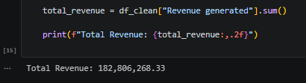
SQL Validation
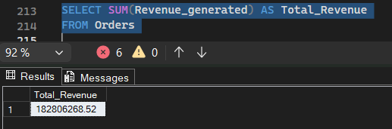
Excel:
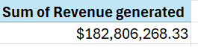
The analysis shows that the business generated a total revenue of 182,806,268.33, representing the total sales value across all customer orders.
8.2 Total Profit
The total profit was calculated by summing all values in the Profit column to measure the overall profitability of the business.
Python Calculation
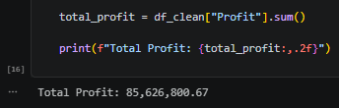
SQL Validation
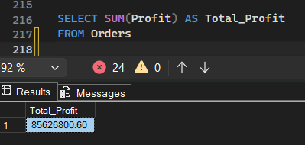
Excel
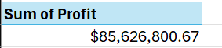

The analysis indicates a total profit of 85,626,800.67, representing the net earnings generated from all completed orders.
8.3 Profit Margin
The profit margin was calculated as the ratio between total profit and total revenue to evaluate the overall profitability of the business.
Python Calculation
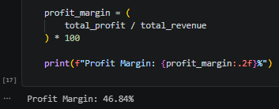
SQL Validation
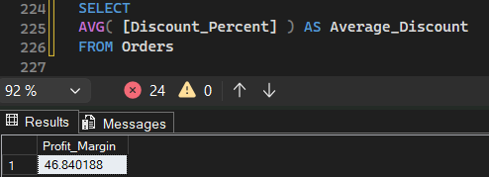
Excel
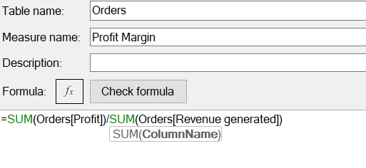
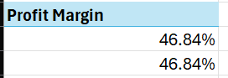

8.4 Average Discount Percentage
The average discount percentage was calculated to determine the typical discount offered across all customer orders. This KPI provides an overview of the company's pricing and promotional strategy.
Python Calculation
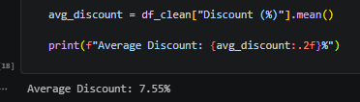
SQL Validation
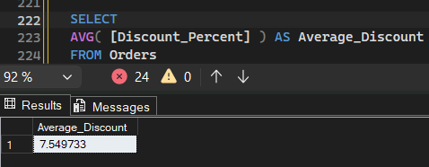
Excel
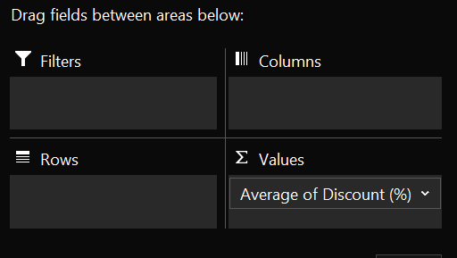
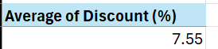
The analysis shows that the average discount percentage is 7.55%, indicating that customers received an average discount of approximately 7.5% per order.
8.5 Revenue and Profit by Quarter
Quarterly revenue and profit were calculated by extracting the quarter from the order date and aggregating both revenue and profit for each quarter. This analysis helps evaluate business performance trends over time.

Python Calculation
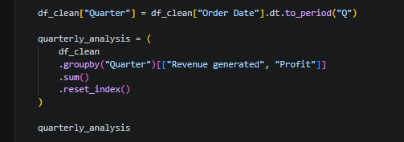

SQL Validation
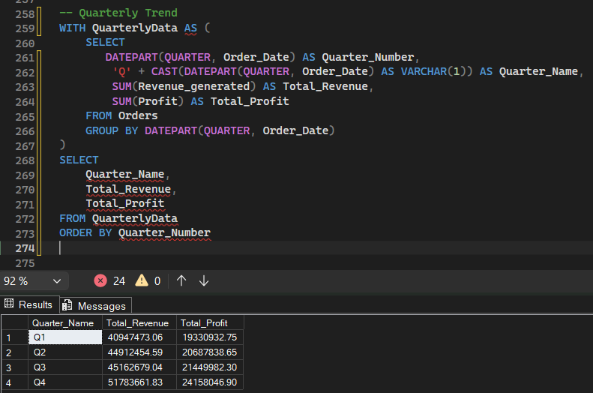

Excel
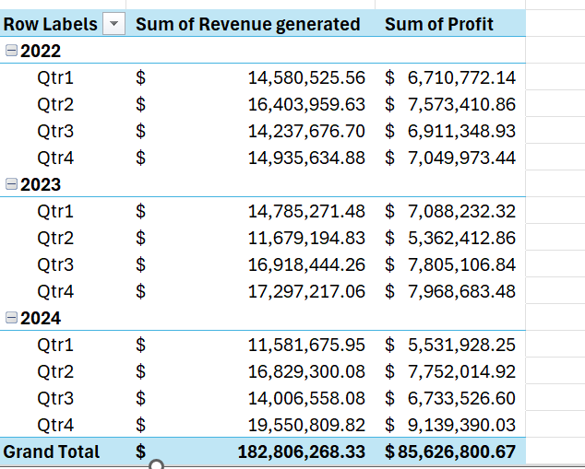
The quarterly analysis summarizes the total revenue and profit generated during each quarter from 2022 Q1 through 2024 Q4. The results show fluctuations in financial
performance across different quarters, enabling comparisons of seasonal trends and identifying periods of stronger or weaker business performance.
8.6 Revenue and Profit by Product
Revenue and profit were aggregated by product type to identify the products that contribute the most to the company's financial performance. The results were then sorted in descending order based on revenue and profit.

Python Calculation
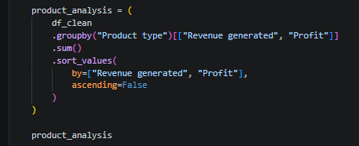
SQL Validation
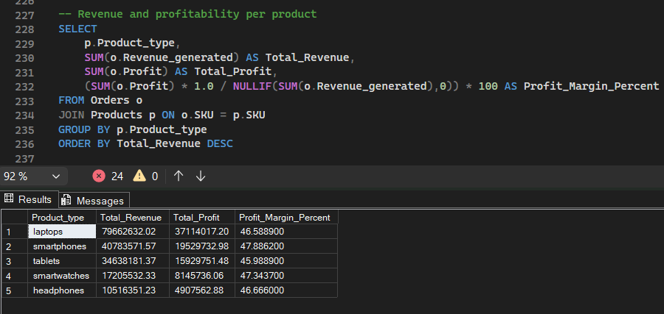
Excel
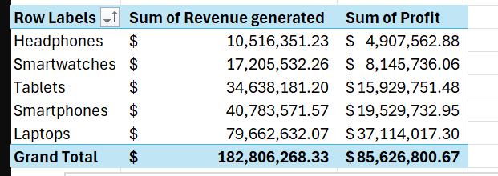
The analysis shows that Laptops generated the highest revenue and profit among all product categories, followed by Smartphones and Tablets. In contrast, Headphones contributed the lowest revenue and profit, indicating a relatively smaller financial impact compared to the other product types.
8.7 Profit by Sales Channel
Profit and the total number of products sold were aggregated for each sales channel to evaluate channel performance and identify the most profitable sales source.

Python Calculation
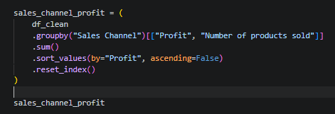
SQL Validation
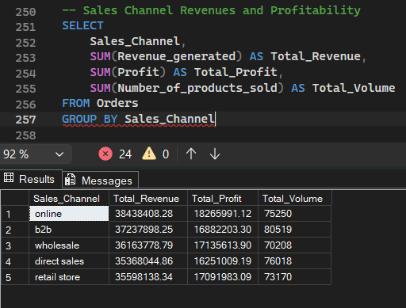

Excel
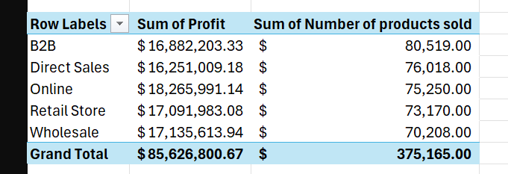
The analysis indicates that the Online sales channel generated the highest total profit, followed by Wholesale, Retail Store, B2B, and Direct Sales. This comparison highlights the relative contribution of each sales channel to the company's overall profitability while also showing the corresponding sales volume.
8.8 Profit Margin by Region
The profit margin was calculated for each region by dividing the total profit by the total revenue. This analysis helps compare regional profitability and identify the regions generating the highest financial returns.
Python Calculation
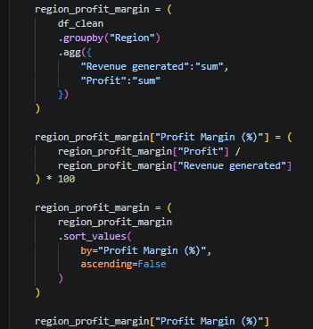
SQL Validation
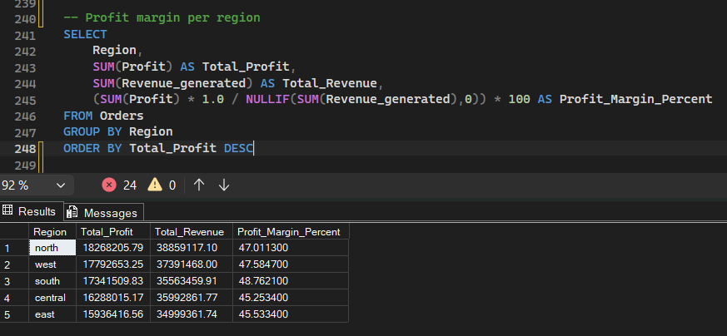
Excel
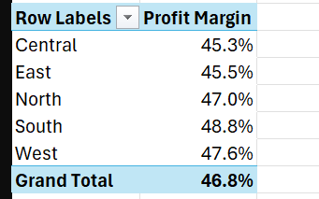
The regional analysis shows that the South region achieved the highest profit margin (48.76%), followed by the West (47.58%) and North (47.01%). The East and Central regions recorded relatively lower profit margins, indicating differences in regional profitability across the business.

8.9 Discount Distribution
Discounts were grouped into three categories to analyze their distribution across customer orders.
Python Calculation
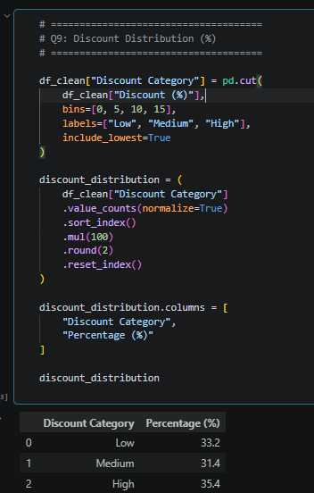

SQL Validation
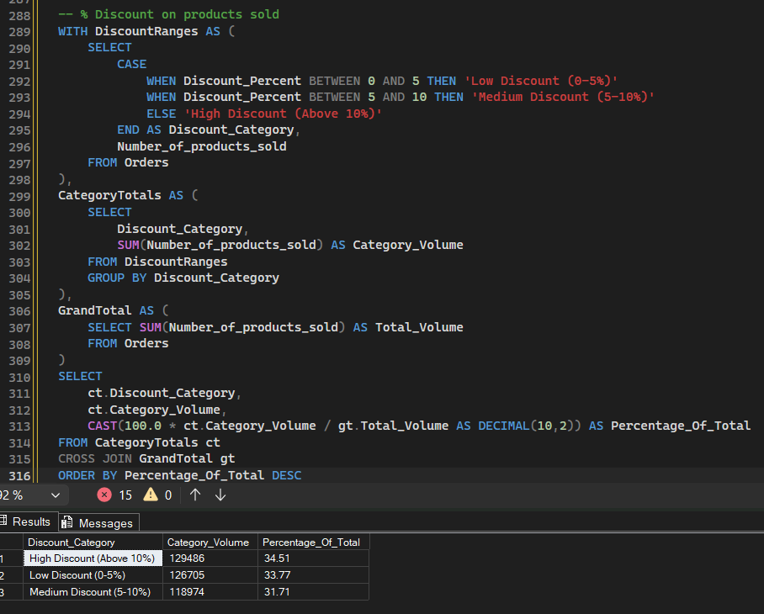
Excel
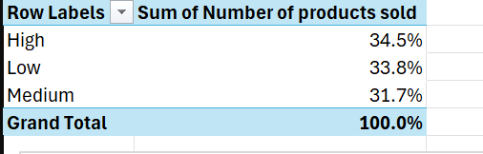
The High discount category represents the largest share of orders (35.4%), followed by Low (33.2%) and Medium (31.4%), indicating a relatively balanced discount distribution.

8.10 Revenue and Profit by Customer Demographics
Revenue and profit were analyzed across customer demographic groups to compare their financial contribution.
Python Calculation
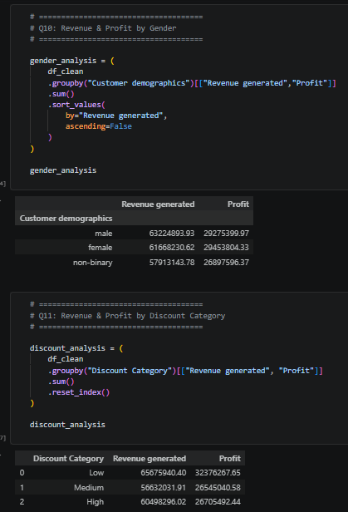
SQL Validation
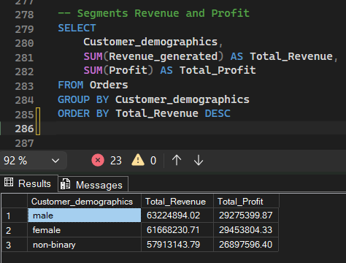
Excel
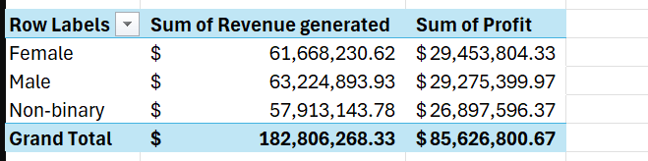
The Male customer segment generated the highest revenue and profit, followed by Female, while the Non-binary segment recorded the lowest financial contribution.
8.11 Revenue and Profit by Discount Category
Revenue and profit were compared across the predefined discount categories to evaluate the financial impact of different discount levels.
Python Calculation
SQL Validation
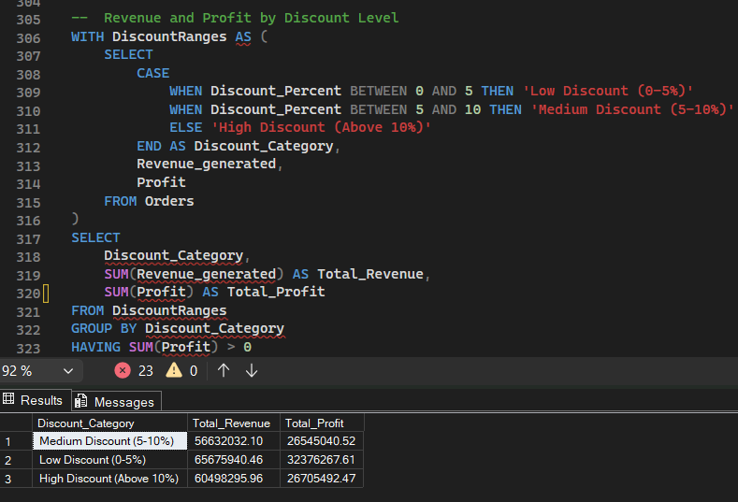
Excel
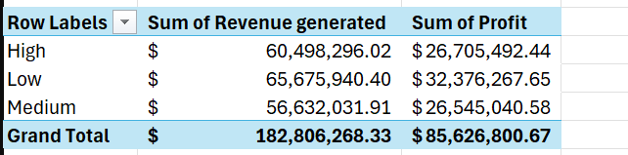
The Low Discount category generated the highest revenue and profit, followed by the High Discount category, while the Medium Discount category recorded the lowest overall financial performance.

8.12 Domain Summary
The Commercial Insights analysis evaluated the organization's overall sales performance by examining key financial metrics such as revenue, profit, profit margin, and average discount. The analysis also explored business performance across different quarters, product types, sales channels, regions, customer demographics, and discount categories.
Overall, the analysis provides a comprehensive view of business performance and highlights the main factors influencing revenue generation and profitability.

Key Insights
- The business generated a total revenue of $182.81M with a total profit of $85.63M.
- The overall profit margin reached 46.84%, indicating strong profitability.
- The average discount offered across all orders was 7.55%.
- Revenue and profit showed noticeable variations across different quarters, reflecting seasonal sales trends.
- Laptops generated the highest revenue and profit among all product categories.
- The Online sales channel achieved the highest total profit.
- The South region recorded the highest profit margin.
- Discount levels were relatively balanced across the three discount categories.
- Revenue and profit were distributed fairly evenly across customer demographic groups.
- Orders with Low Discounts (0–5%) generated the highest revenue and profit, indicating stronger profitability with lower discount levels.

Business Value
This analysis provides a clear understanding of the company's commercial performance by identifying the primary drivers of revenue and profitability. The findings support strategic decisions related to pricing, discount policies, product portfolio optimization,
regional sales performance, and sales channel effectiveness, ultimately helping improve business profitability and growth.
9. Domain 2: Customer Experience & Returns
9.1 Overview
This domain focuses on evaluating customer experience and product return behavior. The analysis examines customer satisfaction, return rates, return losses, sales channels, and return reasons to better understand the factors influencing product returns and customer experience. The generated insights help identify areas for improving customer satisfaction and reducing return-related costs.
Business Questions
The following business questions were addressed during this analysis:
- What is the average return rate?
- How many units were returned?
- What is the average customer satisfaction score?
- What is the total estimated return loss?
- How does customer satisfaction vary by customer demographics?
- Which region has the highest return rate and return loss?
- Which sales channel has the highest return rate and returned units?
- How are returned units distributed by return reason and product type?
- How do return reasons vary across regions?

9.2 Average Return Rate
The average return rate was calculated to measure the percentage of sold products that were returned by customers.
Python Calculation
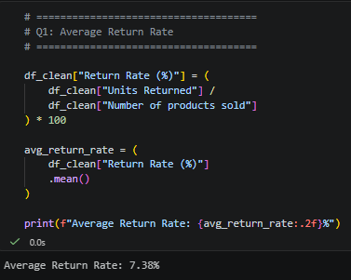
SQL Validation
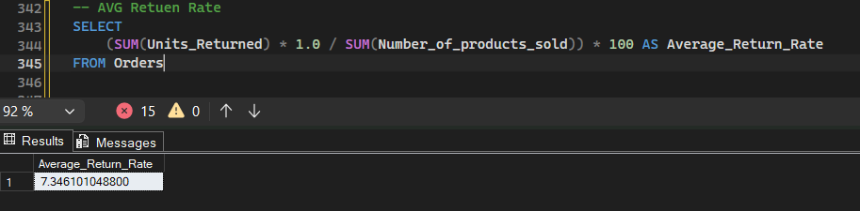
Excel
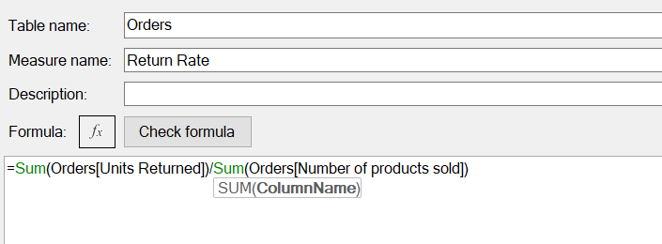
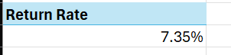
The analysis shows that the average return rate is 7.38%, indicating that a relatively small proportion of sold products were returned by customers.
9.3 Total Units Returned
The total number of returned units was calculated to measure the overall volume of products returned by customers.
Python Calculation
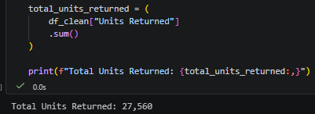
SQL Validation
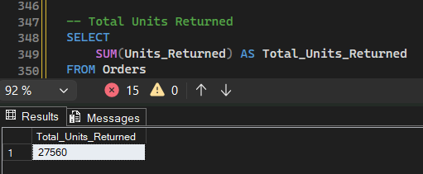
Excel
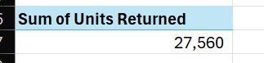
The analysis shows that a total of 27,560 units were returned, providing an overall measure of product .

9.4 Average Customer Satisfaction Score
The average customer satisfaction score was calculated to evaluate the overall satisfaction level of customers based on their ratings.
Python Calculation
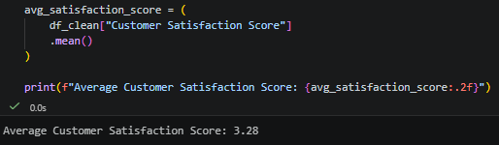
SQL Validation
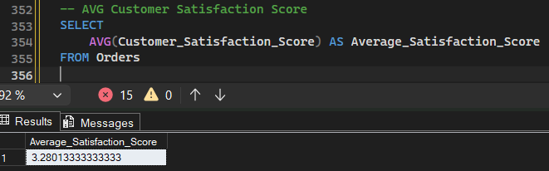
Excel
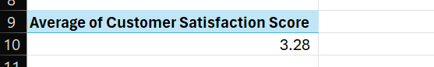
The analysis indicates that the average customer satisfaction score is 3.28, reflecting a moderate level of customer satisfaction across all orders.

9.5 Total Estimated Return Loss
The total estimated return loss was calculated by multiplying the number of returned units by the product price for each order and then summing the estimated loss across all returned products.
Python Calculation
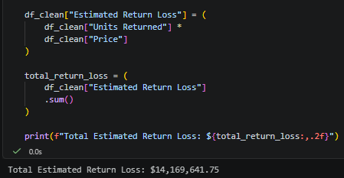
SQL Validation
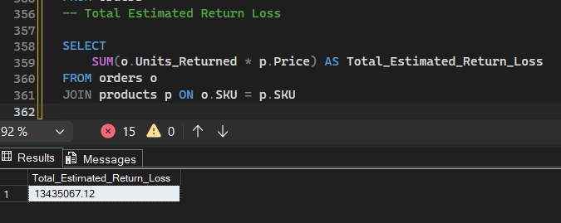
Excel
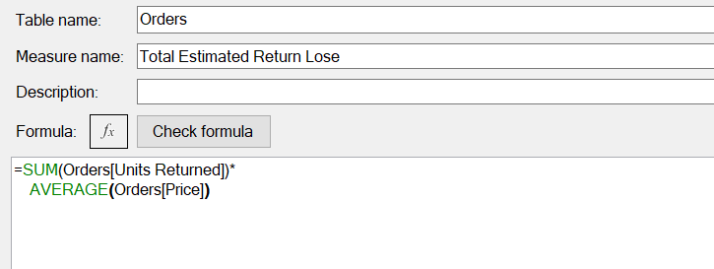
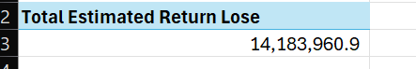
The analysis estimates the total return loss at $14,169,641.75, representing the overall financial impact of returned products based on their selling prices.

9.6 Average Customer Satisfaction Score by Customer Demographics
The average customer satisfaction score was analyzed across different customer demographic groups to compare their overall satisfaction levels.
Python Calculation
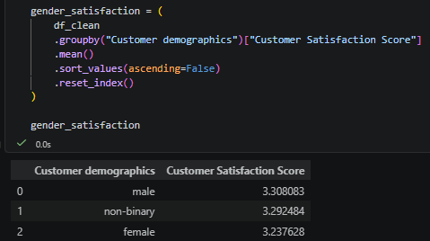
SQL Validation
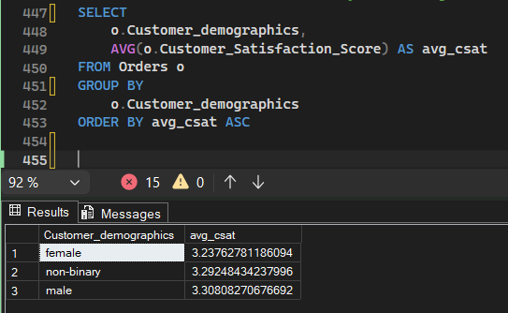

Excel
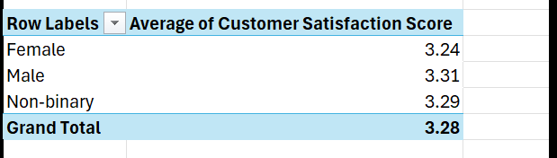
The analysis shows that Male customers reported the highest average satisfaction score (3.31), followed by Non-binary customers (3.29), while Female customers recorded the lowest average score (3.24). Overall, the satisfaction levels are relatively similar across all demographic groups.

9.7 Return Rate & Estimated Return Loss by Region
The return rate and estimated return loss were analyzed across regions to identify the geographical areas with the highest return activity and financial impact.
Python Calculation
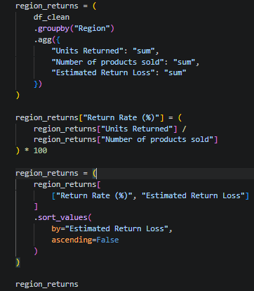
SQL Validation
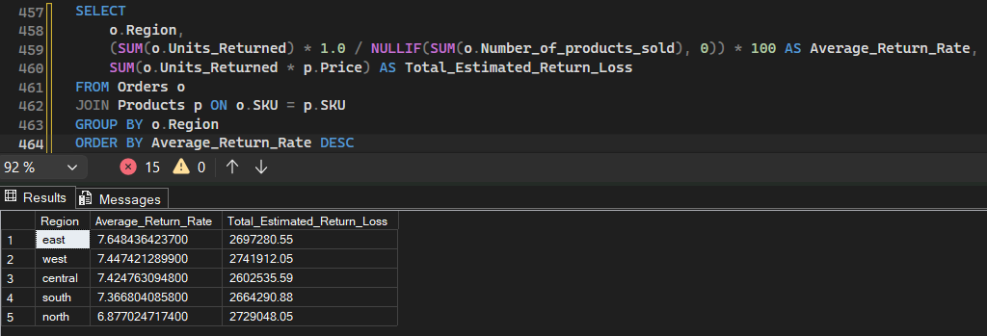

Excel
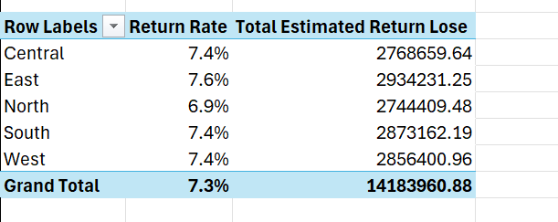
The analysis shows that the North region has the highest estimated return loss ($2.91M), while the East region records the highest return rate (7.65%). This indicates
that although the North experiences the greatest financial loss, the East has the highest proportion of returned products.
9.8 Return Rate & Units Returned by Sales Channel
The total returned units and return rate were analyzed across different sales channels to evaluate their return performance.
Python Calculation
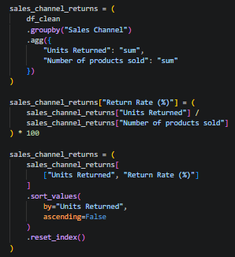
SQL Validation
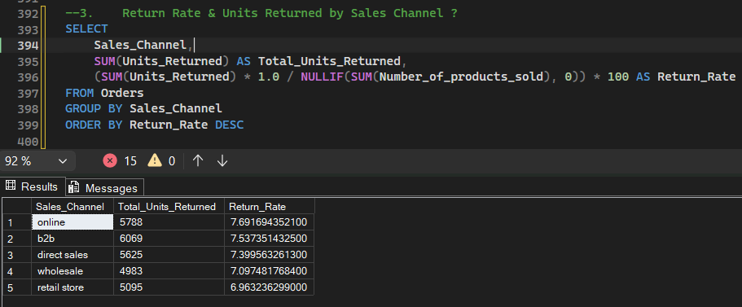

Excel
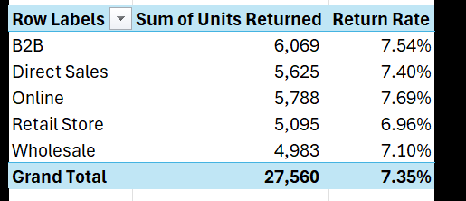
The analysis shows that the B2B sales channel has the highest number of returned units (6,069), while the Online channel records the highest return rate (7.69%). This indicates that although B2B generates the largest return volume, Online has the highest proportion of returned products.

9.9 Units Returned by Return Reason and Product Type
Returned units were analyzed by both return reason and product type to identify which products are most frequently returned for each reason.
Python Calculation
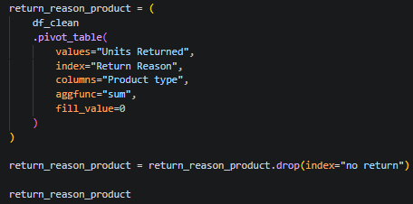
SQL Validation
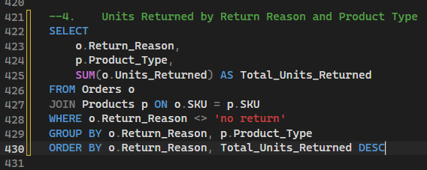
Excel
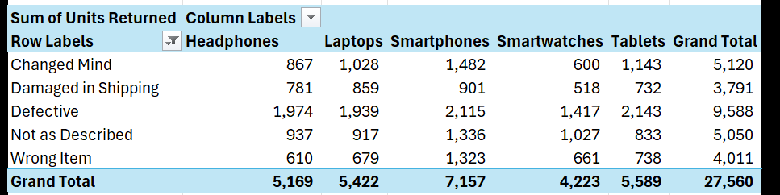
The analysis shows that Defective is the most common return reason across all product types. Smartphones and Tablets recorded the highest number of returned units in most return categories, while Smartwatches generally had the lowest number of returns.
9.10 Return Reasons Across Regions
Return reasons were analyzed across different regions to identify the most common causes of product returns in each geographical area.
Python Calculation
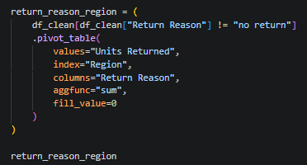
SQL Validation
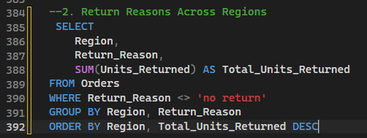
Excel
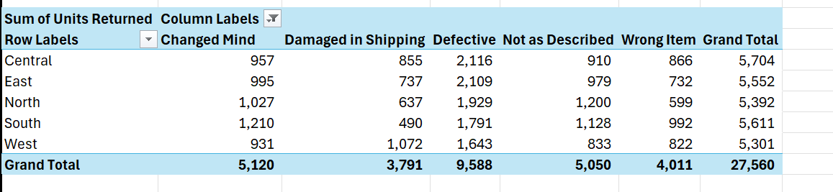
The analysis shows that Defective is the leading return reason across all regions. The Central region recorded the highest number of defective returns (2,116), while the West region had the highest number of returns due to Damaged in Shipping (1,072). Return patterns are generally consistent across regions, with

9.11 Domain Summary
The Customer Experience & Returns analysis evaluated customer satisfaction, product returns, return losses, and return patterns across multiple business dimensions. The analysis measured key performance indicators such as average return rate, total returned units, customer satisfaction score, and estimated return loss. It also compared return behavior across customer demographics, regions, sales channels, product types, and return reasons.
Overall, the analysis identified the primary drivers of product returns and highlighted areas with higher financial impact, providing valuable insights for improving customer satisfaction and reducing return-related losses.

Key Insights
- The average return rate across all orders is 7.38%.
- A total of 27,560 units were returned.
- The average customer satisfaction score is 3.28.
- The estimated financial impact of returned products is approximately $14.17M.
- Male customers reported the highest average satisfaction score (3.31).
- The North region recorded the highest estimated return loss, while the East region showed the highest return rate.
- The B2B sales channel generated the highest number of returned units, whereas the Online channel recorded the highest return rate.
- Defective products were the most common reason for returns across all product categories and regions.

Business Value
This analysis helps identify return trends, evaluate customer satisfaction, and estimate the financial impact of product returns. These insights support decision-making for improving product quality, enhancing customer experience, optimizing sales channels, and reducing return-related costs.

10. Domain 3: Suppliers Performance Dashboard
10.1 Overview
This domain evaluates supplier performance by analyzing product quality, supplier reliability, manufacturing costs, profitability, return rates, and defect rates. The analysis aims to identify the best-performing suppliers, evaluate supplier efficiency, and measure the impact of supplier quality on business performance.
Business Questions
- What is the average supplier quality score?
- What is the average supplier reliability score?
- What is the average return rate?
- What is the average defect rate?
- How does manufacturing cost compare with quality?
- Which supplier generates the highest profit and quality score?
- Which supplier has the highest value score?
- Which supplier has the highest defect rate?
- How does the return rate vary across suppliers?

10.2 Average Supplier Quality Score
The average supplier quality score was calculated to evaluate the overall quality performance of all suppliers.
Python Calculation
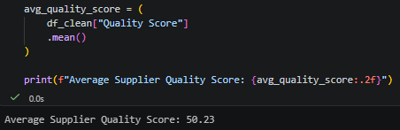

SQL Validation
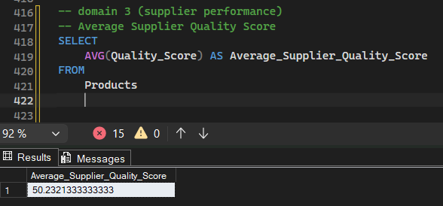
Excel
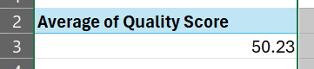
The analysis shows that the average supplier quality score is 50.23, indicating a moderate overall quality level across all suppliers.
10.3 Average Supplier Reliability Score
The average supplier reliability score was calculated to evaluate the overall reliability and consistency of suppliers in fulfilling orders.
Python Calculation
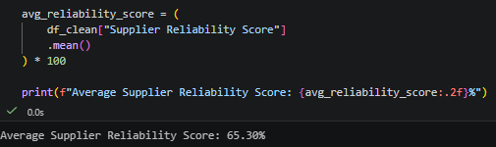
The analysis shows that the average supplier reliability score is 65.30%, indicating a good overall level of supplier reliability.
SQL Validation
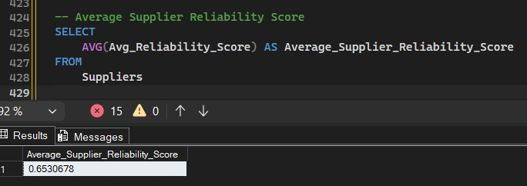
Excel
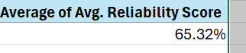
10.4 Average Return Rate
The average return rate was calculated to measure the percentage of sold products that were returned across all suppliers.
Python Calculation
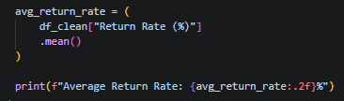
SQL Validation
Excel
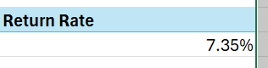
The analysis shows that the average return rate is 7.38%, indicating that approximately 7 out of every 100 sold products were returned.
10.5 Average Defect Rate
The average defect rate was calculated to evaluate the percentage of defective products supplied across all suppliers.
Python Calculation
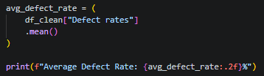
SQL Validation
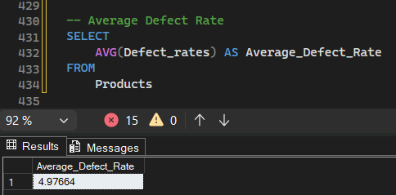
Excel
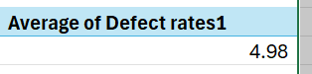
The analysis shows that the average defect rate is 4.98%, indicating that approximately 5% of supplied products were identified as defective.

10.6 Manufacturing Cost vs Quality Score
The average manufacturing cost and average quality score were compared across suppliers to evaluate the relationship between production cost and product quality.
Python Calculation
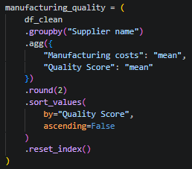
SQL Validation
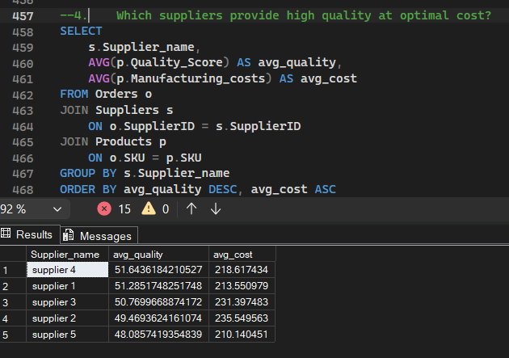

Excel
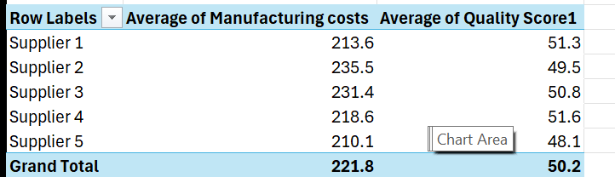
The analysis shows that Supplier 4 achieved the highest average quality score (51.64) with an average manufacturing cost of 218.62. In contrast, Supplier 2 recorded the highest manufacturing cost (235.55) while delivering a lower quality score (49.47), indicating that higher production costs do not necessarily result in better product quality.
10.7 Supplier Profit & Quality Score
Description
Supplier performance was evaluated by comparing total profit with the average quality score for each supplier.
Python Calculation
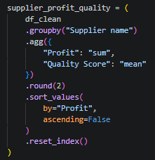

SQL Validation
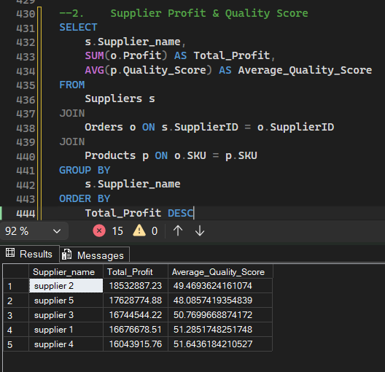
Excel
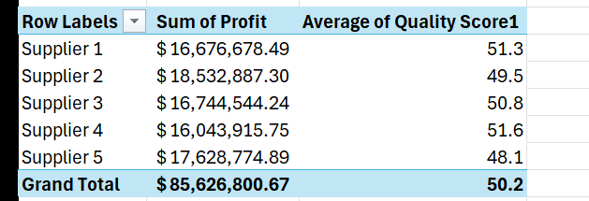
The analysis shows that Supplier 2 generated the highest total profit ($18.53M), while Supplier 4 achieved the highest average quality score (51.64). This indicates that the most profitable supplier is not necessarily the supplier with the highest product quality.
10.8 Supplier Value Score
A supplier value score was calculated by combining the average quality score and supplier reliability score, then dividing the result by the average defect rate to evaluate the overall supplier performance.
Python Calculation
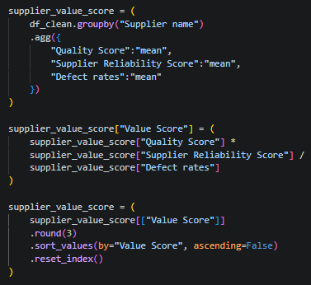
SQL Validation
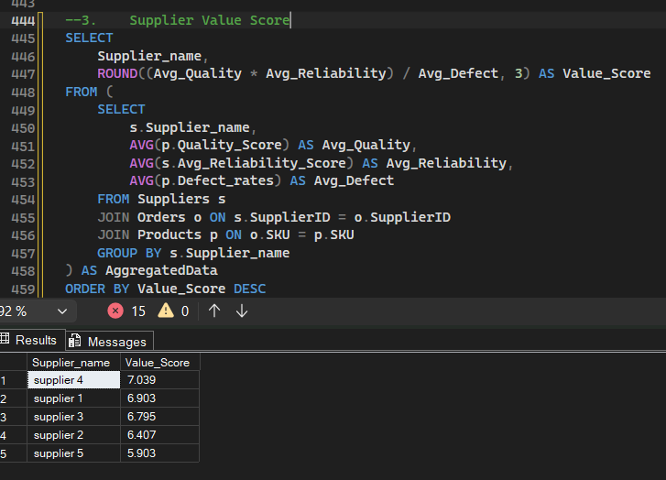

Excel
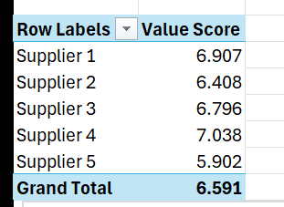
The analysis shows that Supplier 4 achieved the highest value score (7.038), indicating the best overall balance between quality, reliability, and defect rate. Supplier 5 recorded the lowest value score (5.902), suggesting room for performance improvement.
10.9 Average Defect Rate by Supplier
The average defect rate was calculated for each supplier to identify suppliers with the highest proportion of defective products.
Python Calculation
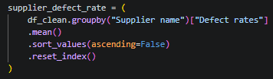

SQL Validation
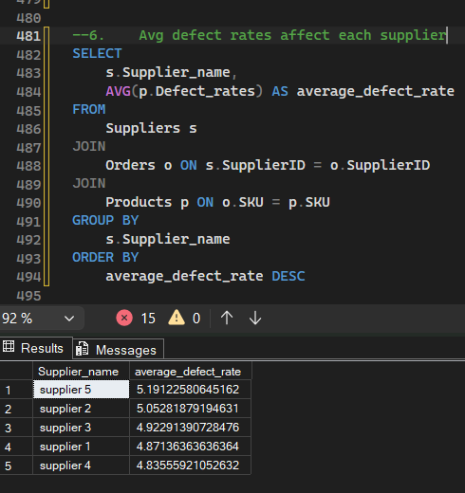
Excel
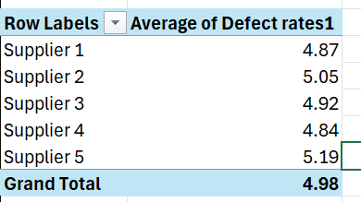
The analysis shows that Supplier 5 recorded the highest average defect rate (5.19%), followed by Supplier 2 (5.05%). In contrast, Supplier 4 achieved the lowest defect rate (4.84%), indicating better product quality and manufacturing consistency.
10.10 Average Return Rate by Supplier
The average return rate was calculated for each supplier to compare return performance across suppliers.

Python Calculation
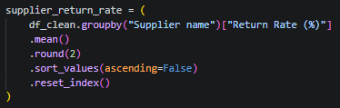
SQL Validation
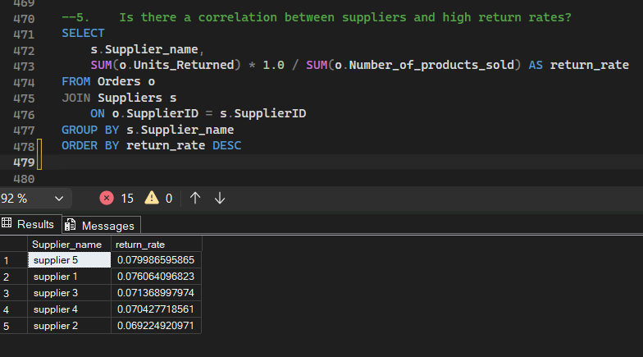
Excel
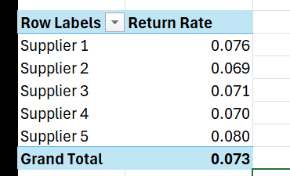
The analysis shows that Supplier 5 recorded the highest average return rate (7.72%), followed by Supplier 1 (7.45%). Meanwhile, Supplier 2 achieved the lowest return rate (7.18%), indicating better return performance compared to the other suppliers.

10.11 Domain Summary
The Suppliers Performance analysis evaluated supplier efficiency by examining quality, reliability, defect rates, return rates, manufacturing costs, profitability, and overall supplier value. The analysis compared suppliers across multiple performance indicators to identify top-performing suppliers and areas requiring improvement.
Overall, the analysis provides a comprehensive assessment of supplier performance and supports supplier evaluation based on quality, operational efficiency, and financial contribution.

Key Insights
- The average supplier quality score is 50.23.
- The average supplier reliability score reached 65.30%.
- The overall average return rate is 7.38%.
- The average defect rate across suppliers is 4.98%.
- Supplier 4 achieved the highest quality score while maintaining a moderate manufacturing cost.
- Supplier 2 generated the highest total profit among all suppliers.
- Supplier 4 recorded the highest supplier value score (7.038), reflecting the best balance between quality, reliability, and defect rate.
- Supplier 5 had the highest defect rate (5.19%) and the highest average return rate (7.72%).

Business Value
This analysis provides a comprehensive evaluation of supplier performance by combining operational, quality, and financial metrics. The findings support supplier selection, performance monitoring, quality improvement initiatives, and strategic sourcing decisions, helping the organization strengthen supplier relationships while reducing quality issues and return-related costs.

11. Domain 4: Inventory
11.1 Overview
This domain analyzes inventory performance by evaluating production volume, stock availability, inventory gaps, stockout risks, product profitability, and SKU performance. The analysis aims to optimize inventory management, identify stock shortages, and evaluate product performance across different inventory metrics.
Business Questions
- What is the total production volume?
- What is the total number of units sold?
- What is the total stock available?
- What is the inventory gap?
- How many products are available?
- How are SKUs distributed by stockout risk?
- Which product type has the highest production volume?
- Which product type has the largest inventory gap?
- Which products have the highest profit margin?
- Which SKUs are the top-selling products?
- How does profit margin vary across price ranges?
- Which product type has the highest defect rate?

11.2 Total Production Volume
The total production volume was calculated to measure the overall number of units produced across all products.
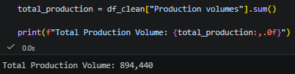
Excel
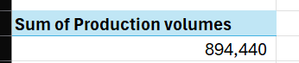
SQL Validation
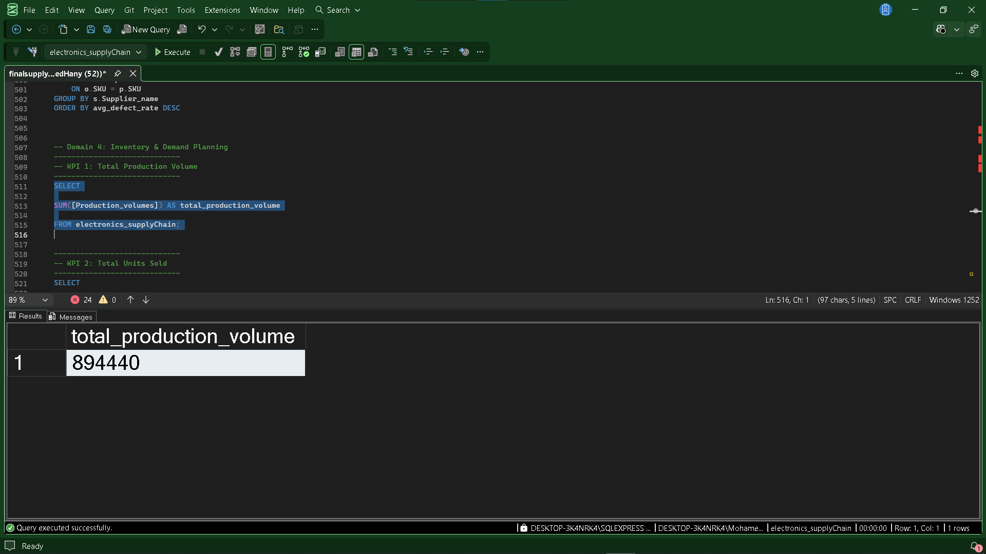

The analysis shows that the total production volume is 894,440 units, representing the overall manufacturing output available for inventory management.

11.3 Total Units Sold
The total number of units sold was calculated to measure the overall sales volume across all products.
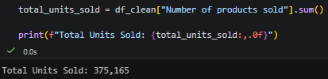
Excel
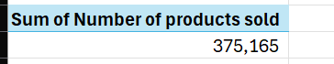
SQL Validation
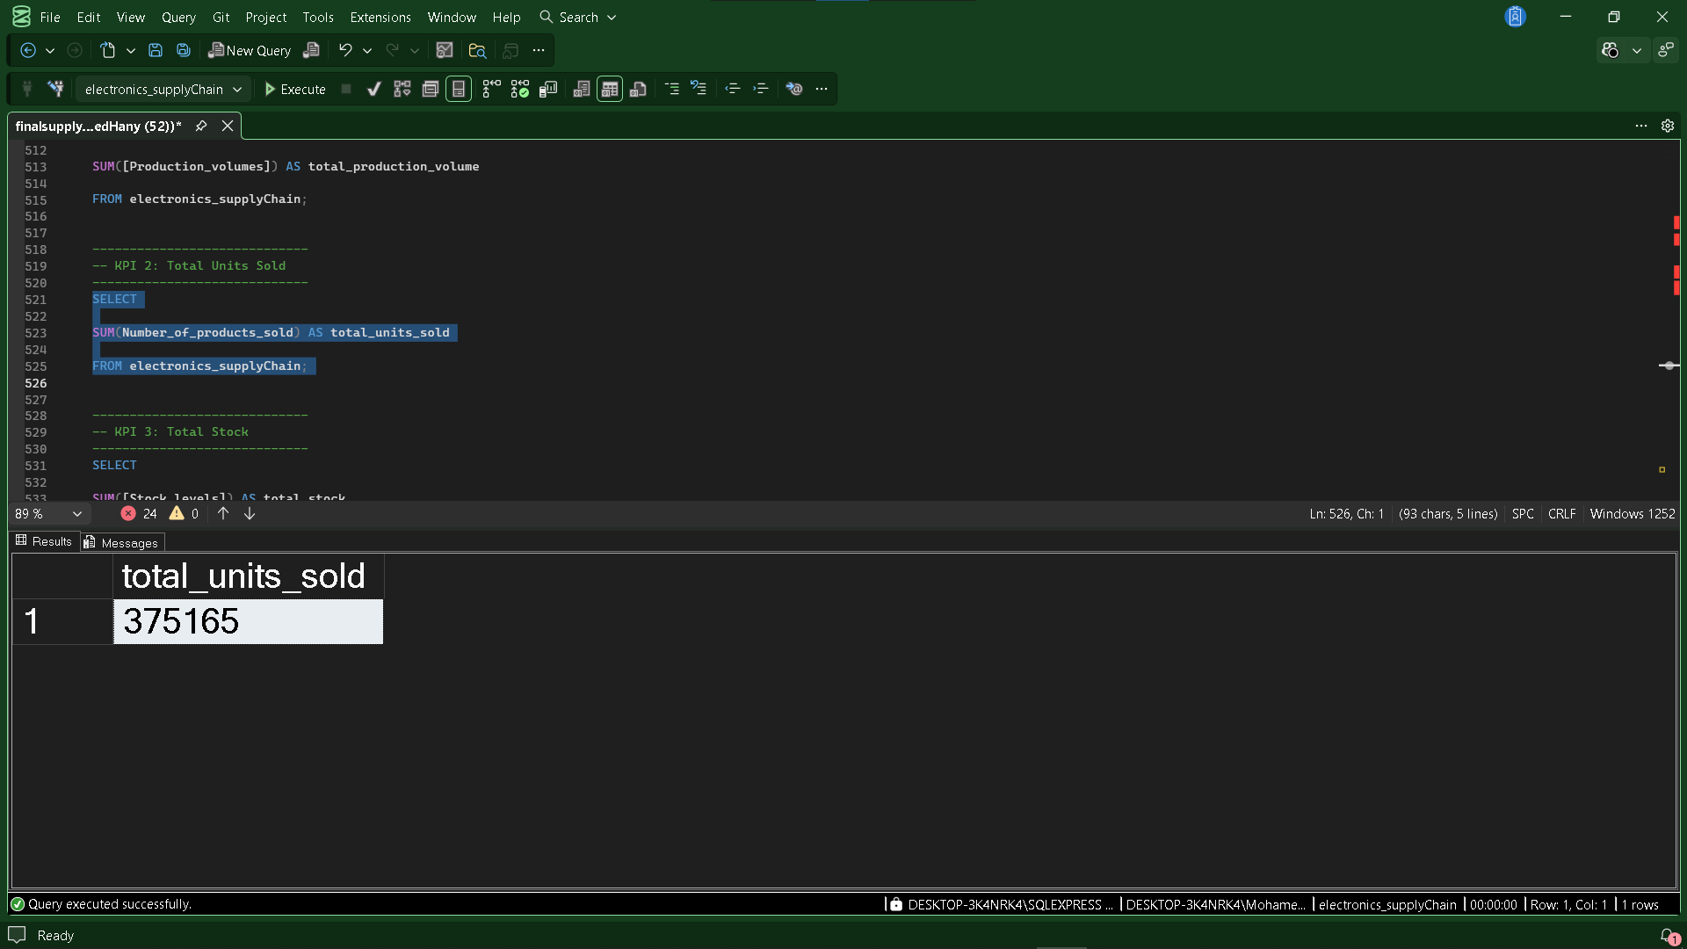
The analysis shows that a total of 375,165 units were sold, representing the overall sales volume during the analyzed period.

11.4 Total Stock Available
The total stock available was calculated to determine the overall inventory currently available across all products.
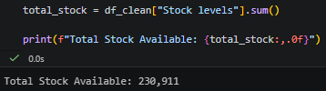
Excel
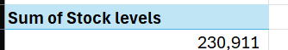
SQL Validation
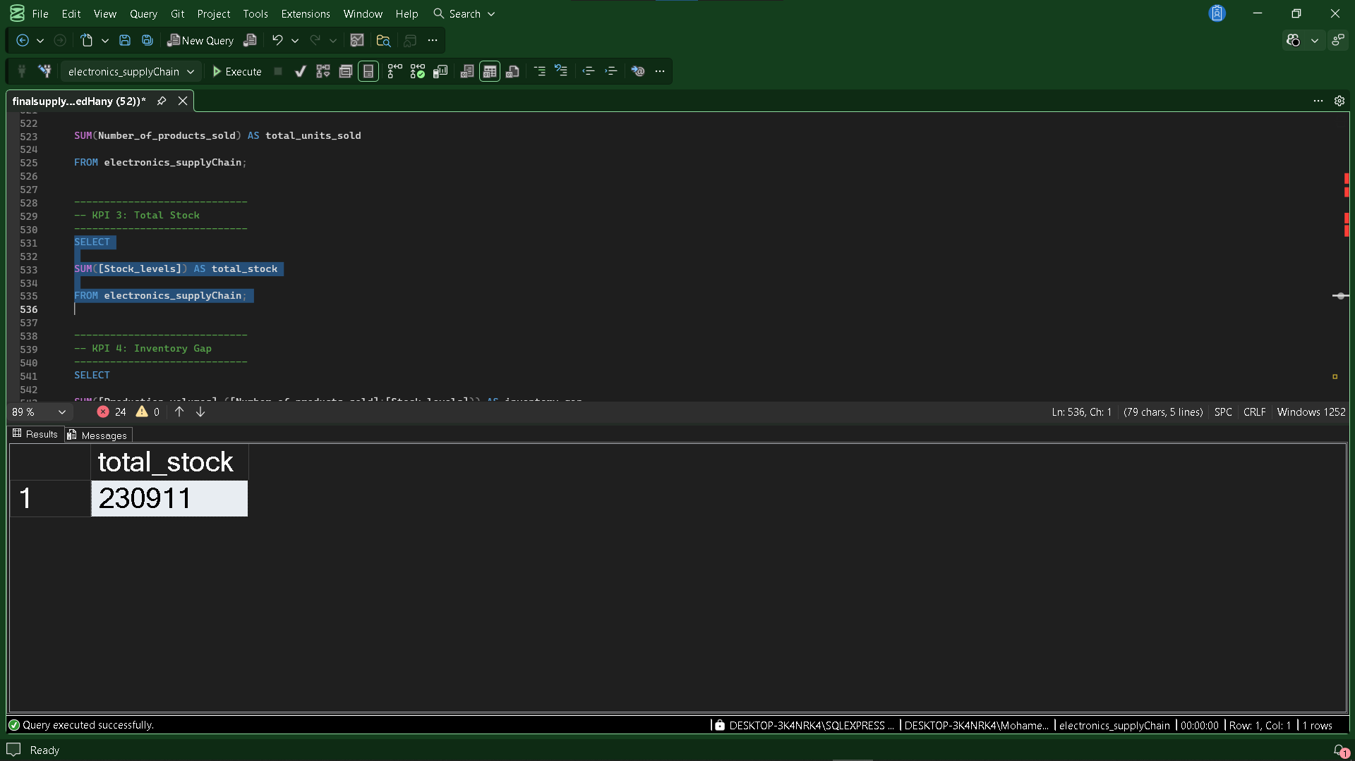
The analysis shows that the total stock available is 230,911 units, representing the inventory currently available to support future customer demand.

11.5 Inventory Gap
The inventory gap was calculated by subtracting the total units sold and available stock from the total production volume to measure the remaining inventory difference.
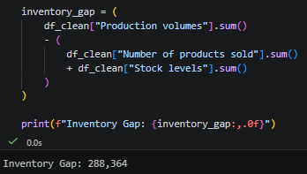
Excel
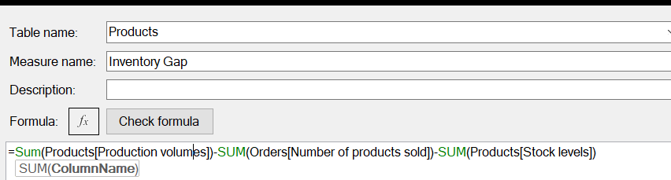
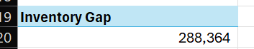

SQL Validation
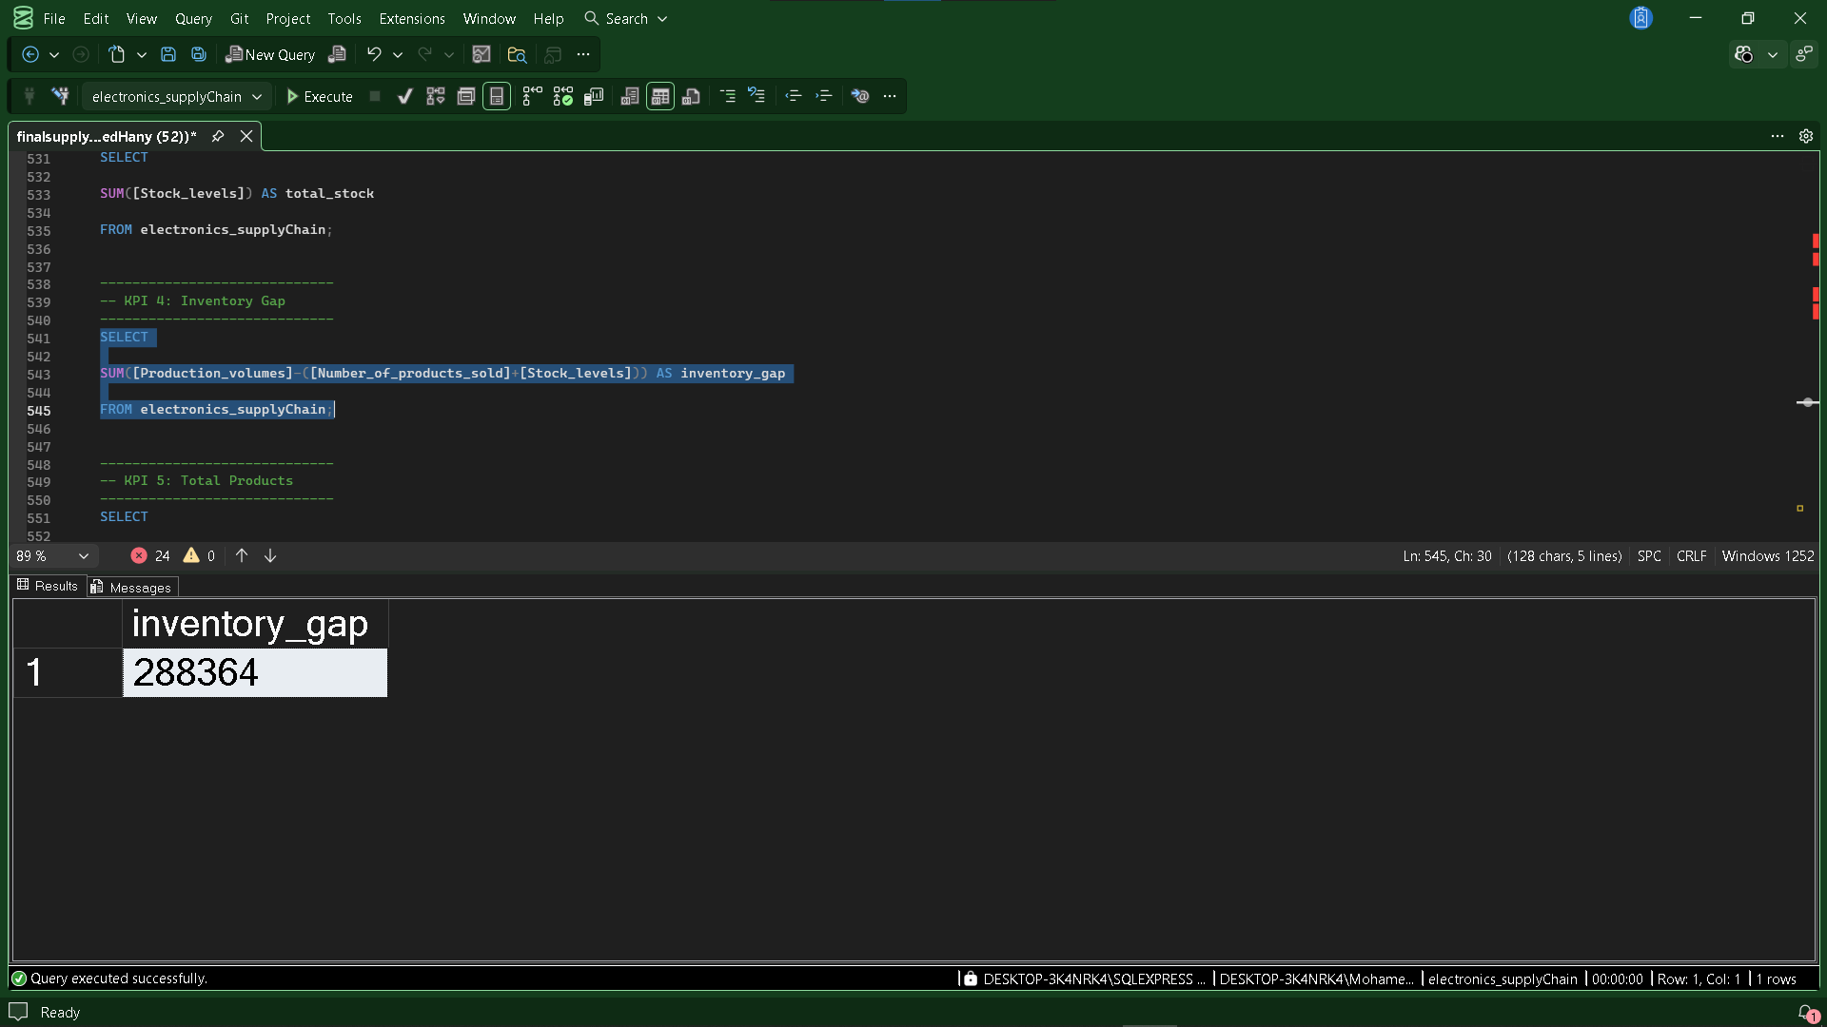
The analysis shows that the inventory gap is 288,364 units, indicating the difference between total production and the combined quantity of sold and available stock.
11.6 Number of Products
The total number of unique products was calculated by counting the distinct SKUs available in the dataset.
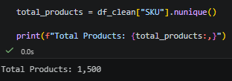
Excel
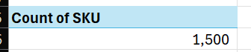

SQL Validation
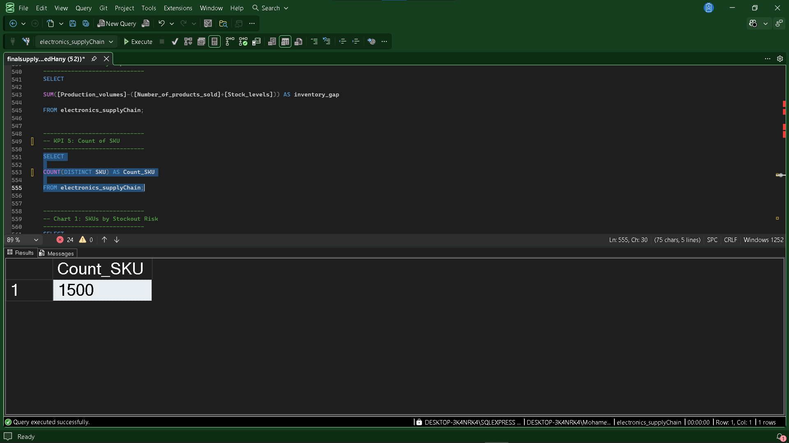
The analysis shows that the inventory consists of 1,500 unique products, representing the complete product portfolio available for analysis.
11.7 SKU Distribution by Stockout Risk
Products were classified based on their stockout status to determine the percentage of SKUs that are at risk of stock shortages.
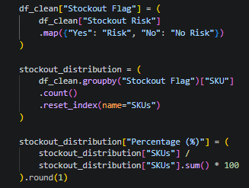

Excel
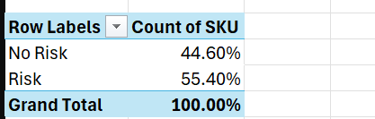
SQL Validation
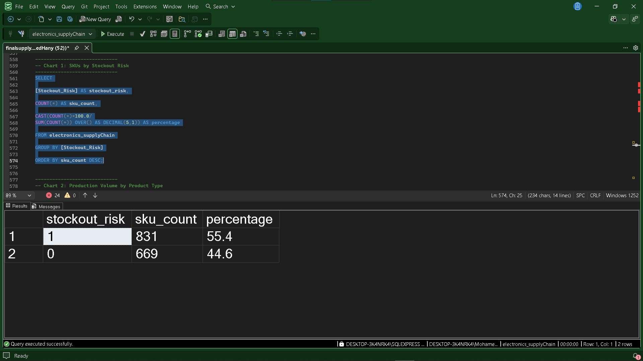

The analysis shows that 55.4% of SKUs are classified as Risk, while 44.6% are classified as No Risk, indicating that more than half of the products have a potential stockout risk.

11.8 Production Volume by Product Type
The percentage of total production volume was calculated for each product type to identify the products contributing most to overall production.
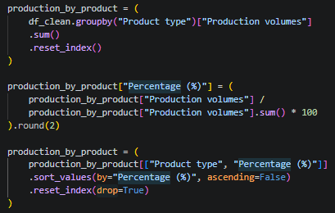
Excel
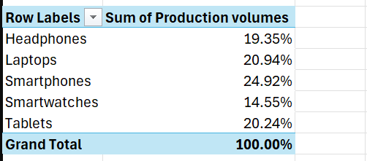

SQL Validation
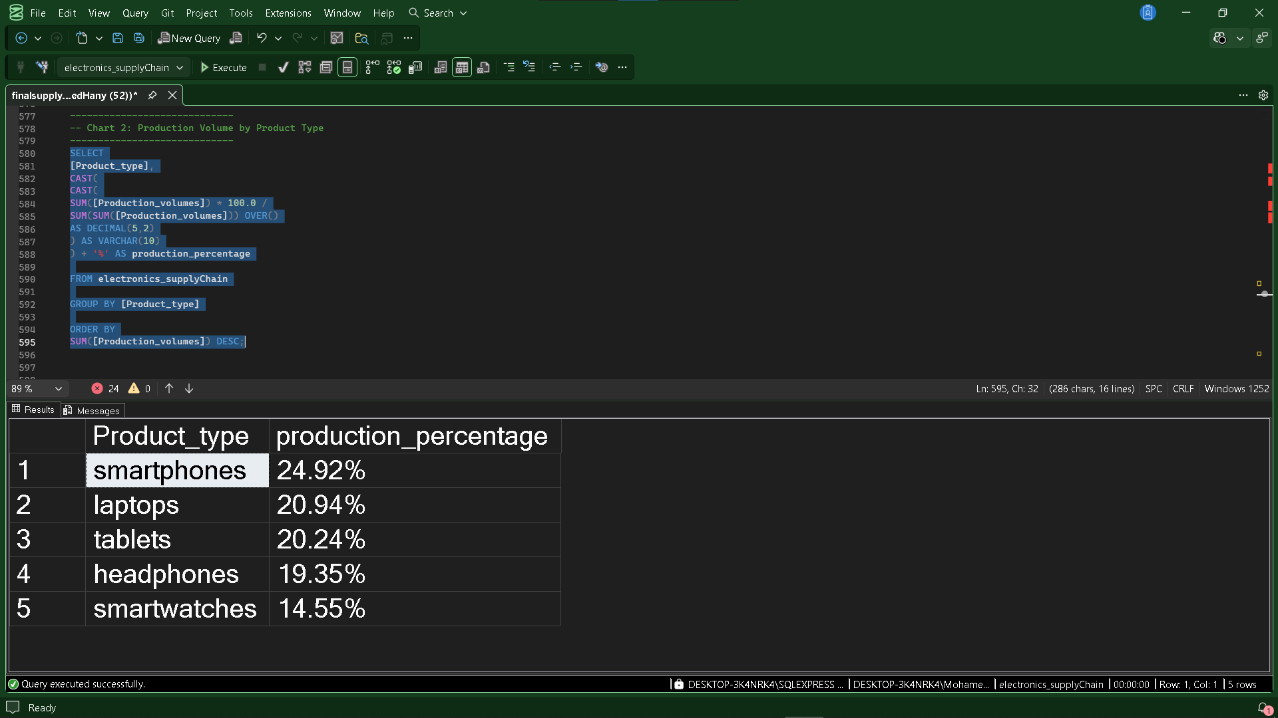
The analysis shows that Smartphones account for the largest share of production (24.92%), followed by Laptops (20.94%) and Tablets (20.24%), while Smartwatches represent the smallest production share (14.55%).

11.9 Inventory Gap & Stock Level by Product Type
Inventory gap and available stock were compared across product types to evaluate inventory availability and identify products with the largest inventory shortages.
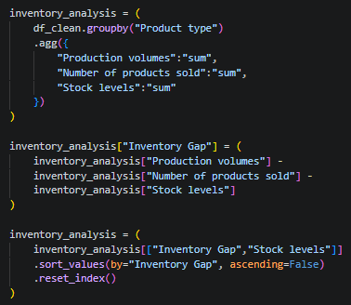
Excel
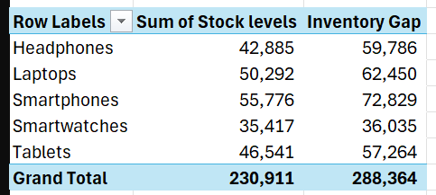

The analysis shows that Smartphones have the largest inventory gap (72,829 units) while also maintaining the highest stock level (55,776 units). In contrast, Smartwatches recorded the smallest inventory gap (36,035 units) and the lowest stock level (35,417 units).
11.10 Profit Margin & Units Sold by Product Type
The total units sold and profit margin were compared across product types to evaluate both sales performance and profitability.
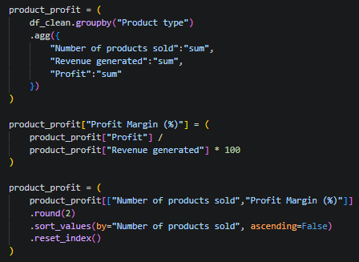
Excel
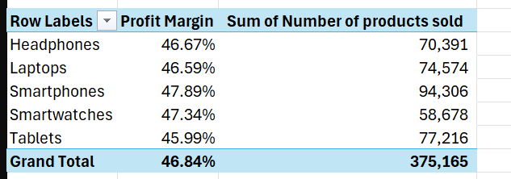

SQL Validation
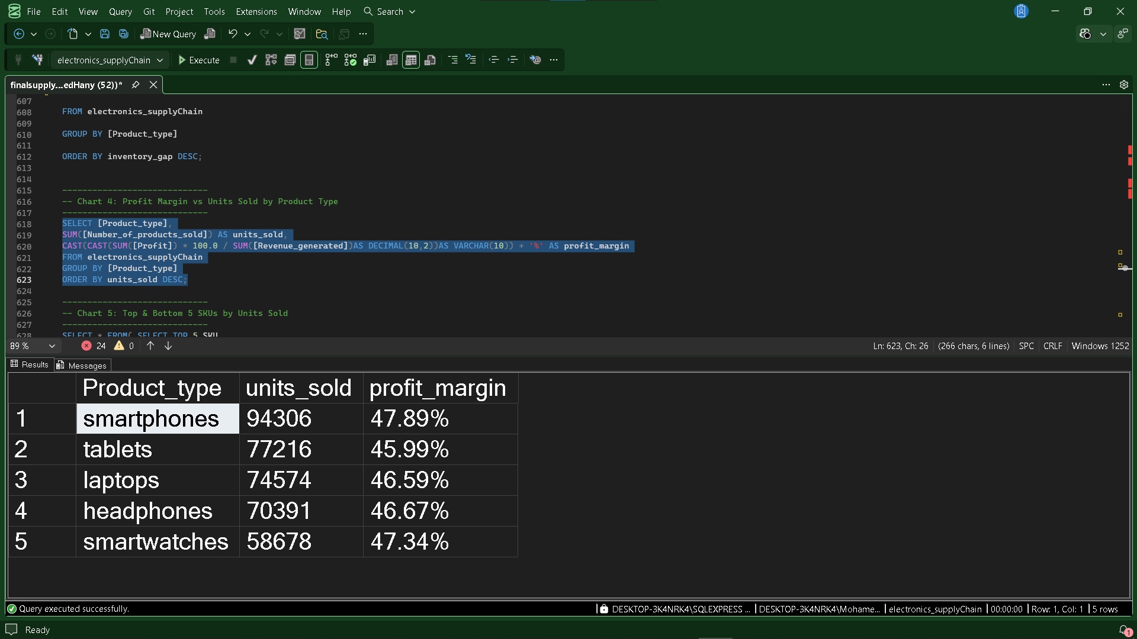
The analysis shows that Smartphones achieved the highest sales volume (94,306 units) and the highest profit margin (47.89%). Although Tablets ranked second in units sold (77,216), they recorded the lowest profit margin (45.99%) among all product types.
11.11 Top & Bottom Selling SKUs
The top five and bottom five SKUs were identified based on the total number of units sold to highlight the best- and worst-performing products.
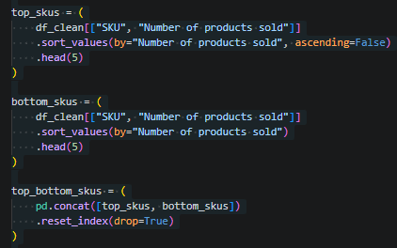

Excel
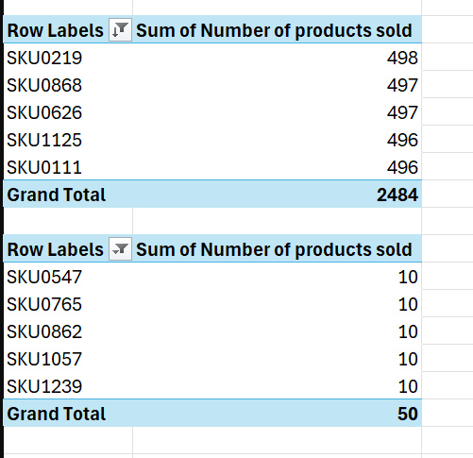
SQL Validation
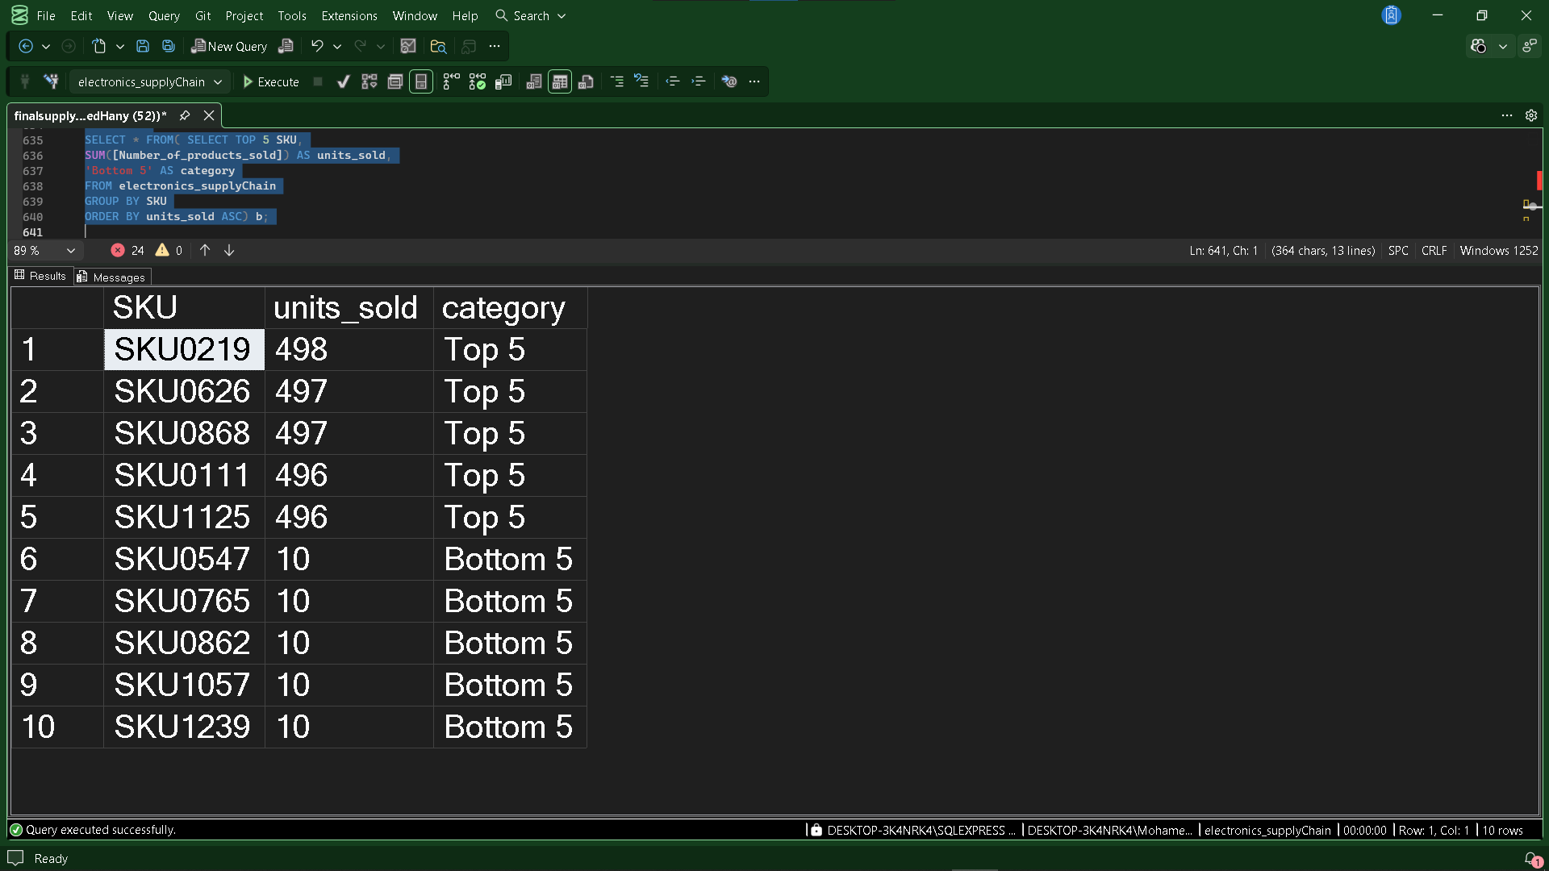
The analysis shows that SKU0219 recorded the highest sales with 498 units, followed by SKU0626 and SKU0868 with 497 units each. On the other hand, SKU1057, SKU0765, SKU0547, SKU1239, and SKU0862 were the lowest-selling products, each recording only 10 units sold.
11.12 Profit Margin by Price Range
Products were grouped into different price ranges to compare profitability across pricing segments.
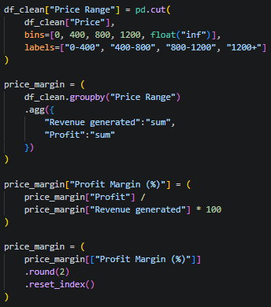
Excel
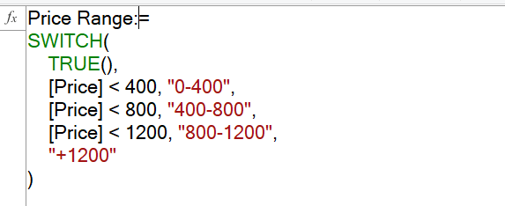
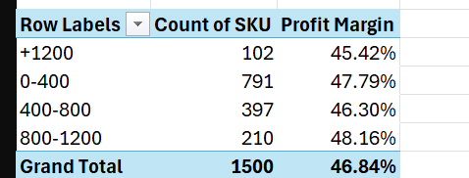
SQL Validation
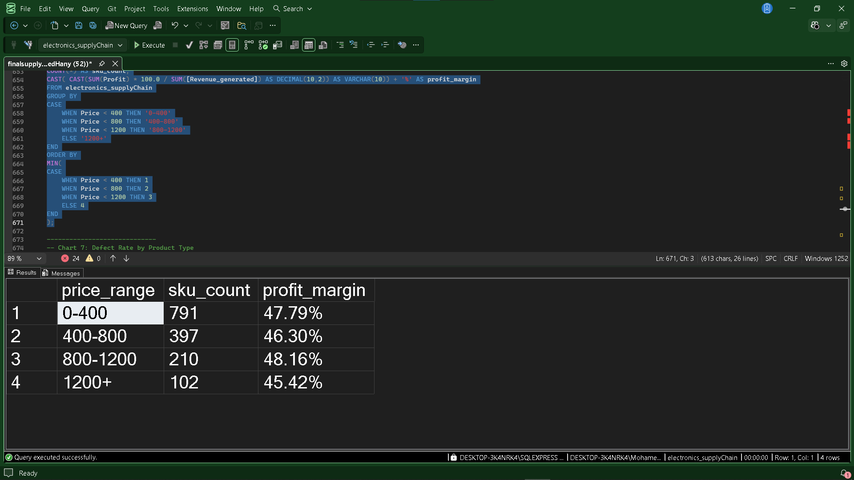
The analysis shows that products priced between 800–1200 achieved the highest profit margin (48.16%), while products priced above 1200 recorded the lowest profit margin (45.42%). This indicates that mid-to-high priced products generate better profitability than premium-priced products.

11.13 Defect Rate by Product Type
The average defect rate was analyzed across product types to identify products with the highest proportion of manufacturing defects.
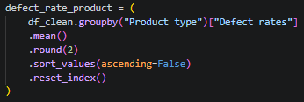
Excel
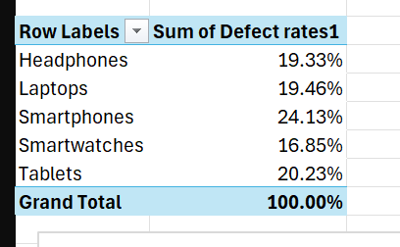
SQL Validation
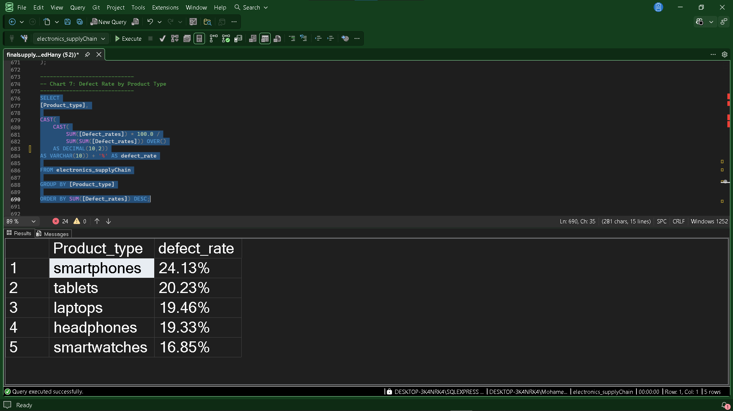
The analysis shows that Smartwatches recorded the highest average defect rate (5.42%), followed by Tablets (5.12%). Laptops achieved the lowest defect rate (4.73%), indicating better product quality compared to the other product categories.
11.14 Domain Summary
The Inventory analysis evaluated production output, inventory availability, sales performance, stockout risk, profitability, and product quality across different product categories. The analysis measured key inventory metrics, identified inventory shortages, evaluated SKU performance, and compared profitability across price ranges to support effective inventory management.
Overall, the analysis provides a comprehensive view of inventory performance and highlights opportunities to improve stock planning, product availability, and operational efficiency.

Key Insights
- The total production volume reached 894,440 units.
- A total of 375,165 units were sold, while 230,911 units remain in stock.
- The overall inventory gap is 288,364 units.
- The inventory consists of 1,500 unique products.
- 55.4% of SKUs are classified as Stockout Risk, indicating that more than half of the products may require inventory attention.
- Smartphones account for the largest share of production (24.92%) and also recorded the highest sales volume (94,306 units).
- Smartphones have the largest inventory gap (72,829 units), while Smartwatches have the smallest inventory gap (36,035 units).
- Products priced between 800–1200 achieved the highest profit margin (48.16%).
- SKU0219 is the best-selling product (498 units), while several SKUs recorded only 10 units sold.
- Smartwatches recorded the highest average defect rate (5.42%), whereas Laptops achieved the lowest defect rate (4.73%).

Business Value
This analysis provides valuable insights into inventory performance by evaluating production, stock availability, sales, profitability, and product quality. The findings support inventory planning, stock replenishment, product prioritization, and pricing strategies, helping improve inventory utilization, reduce stockout risks, and enhance overall operational efficiency.
12. Domain 5: Shipping Analytics
12.1 Overview
This domain analyzes shipping performance by evaluating shipping costs, lead times, delivery times, regional shipping efficiency, delivery performance, and the financial impact of delivery status. The analysis helps assess logistics efficiency, optimize shipping operations, and improve customer delivery performance.
Business Questions
- What is the total shipping cost?
- What is the average lead time?
- What is the average shipping time?
- What is the average shipping cost per shipment?
- How do shipping cost and units shipped vary by region?
- How do shipping cost and units sold vary by product type?
- Which region has the best delivery performance?
- What percentage of orders are delivered on time versus delayed?
- What is the average shipping duration by region?
- How does delivery status impact profit?

12.2 Total Shipping Cost
The total shipping cost was calculated to measure the overall transportation expenses across all shipments.
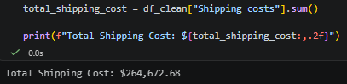
Excel
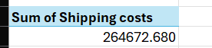
SQL Validation

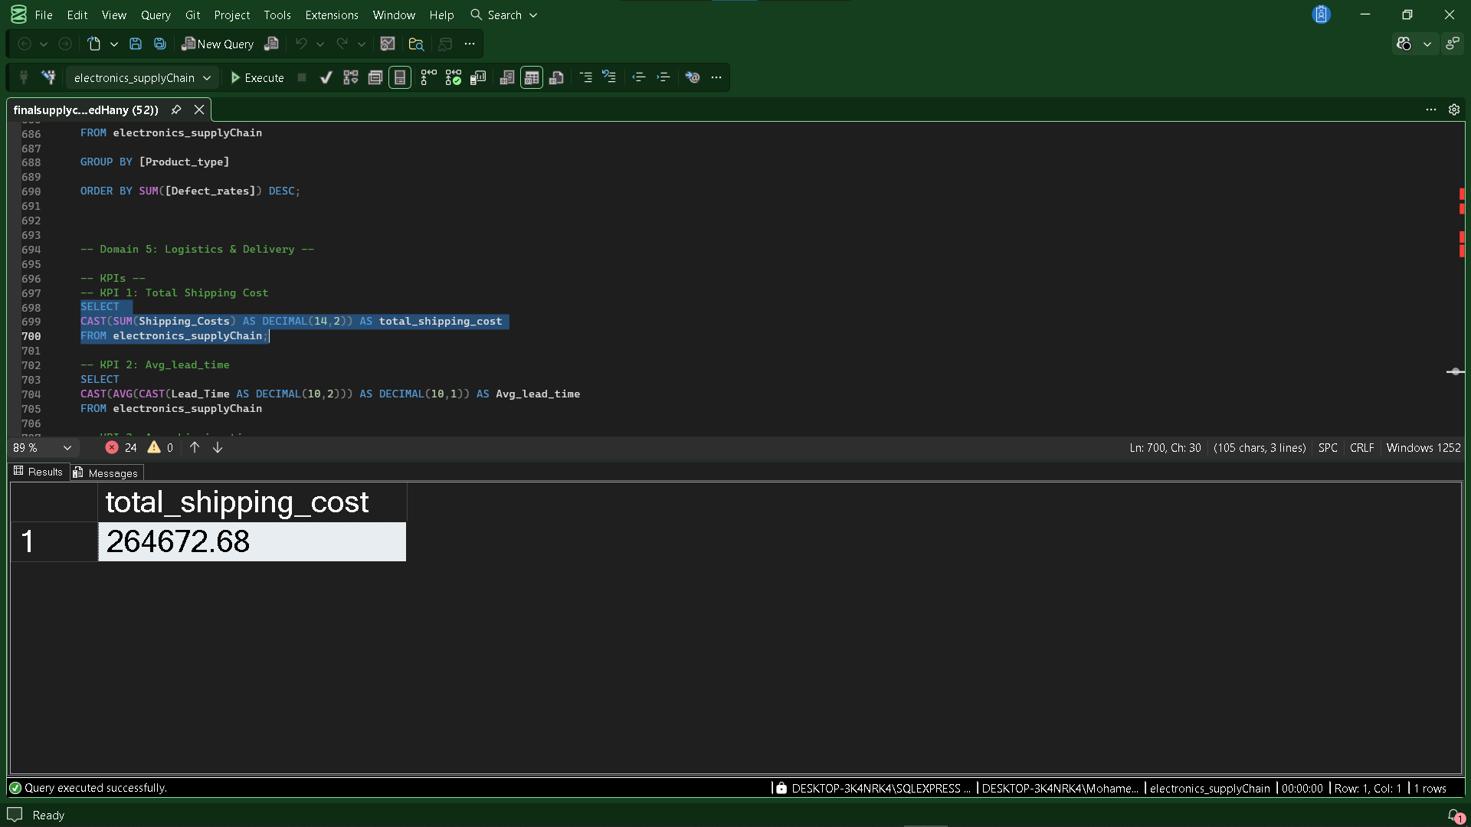
The analysis shows that the total shipping cost is $264,672.68, representing the overall logistics cost incurred during the analyzed period.

12.3 Average Lead Time
The average lead time was calculated to measure the average number of days required before products are ready for shipment.
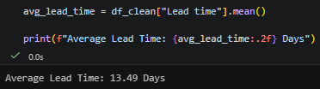
Excel
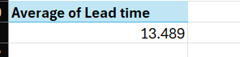
SQL Validation
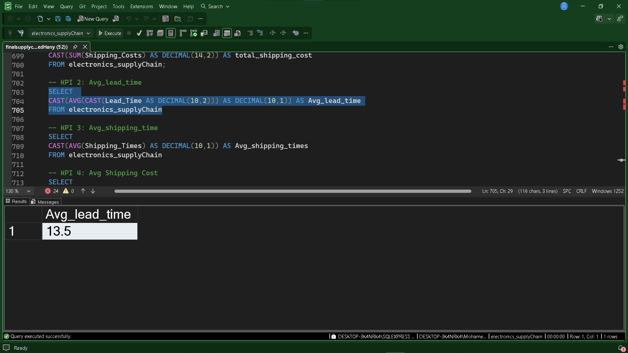
The analysis shows that the average lead time is 13.49 days, indicating the typical preparation time required before orders are shipped.

12.4 Average Shipping Time
The average shipping time was calculated to measure the average number of days required to deliver products after shipment.
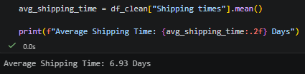
Excel
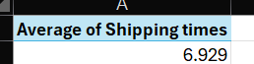
SQL Validation
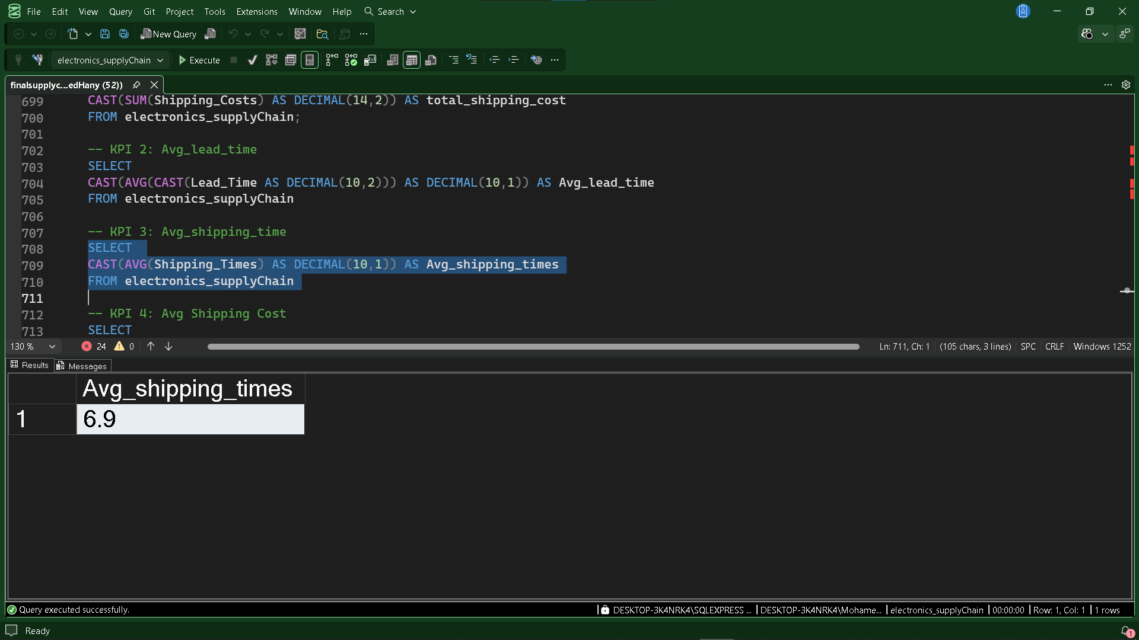
The analysis shows that the average shipping time is 6.93 days, representing the typical delivery duration from shipment to customer.

12.5 Average Shipping Cost per Shipment
The average shipping cost per shipment was calculated to measure the average logistics cost incurred for each shipment.
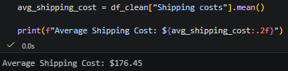
Excel
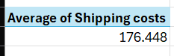
SQL Validation
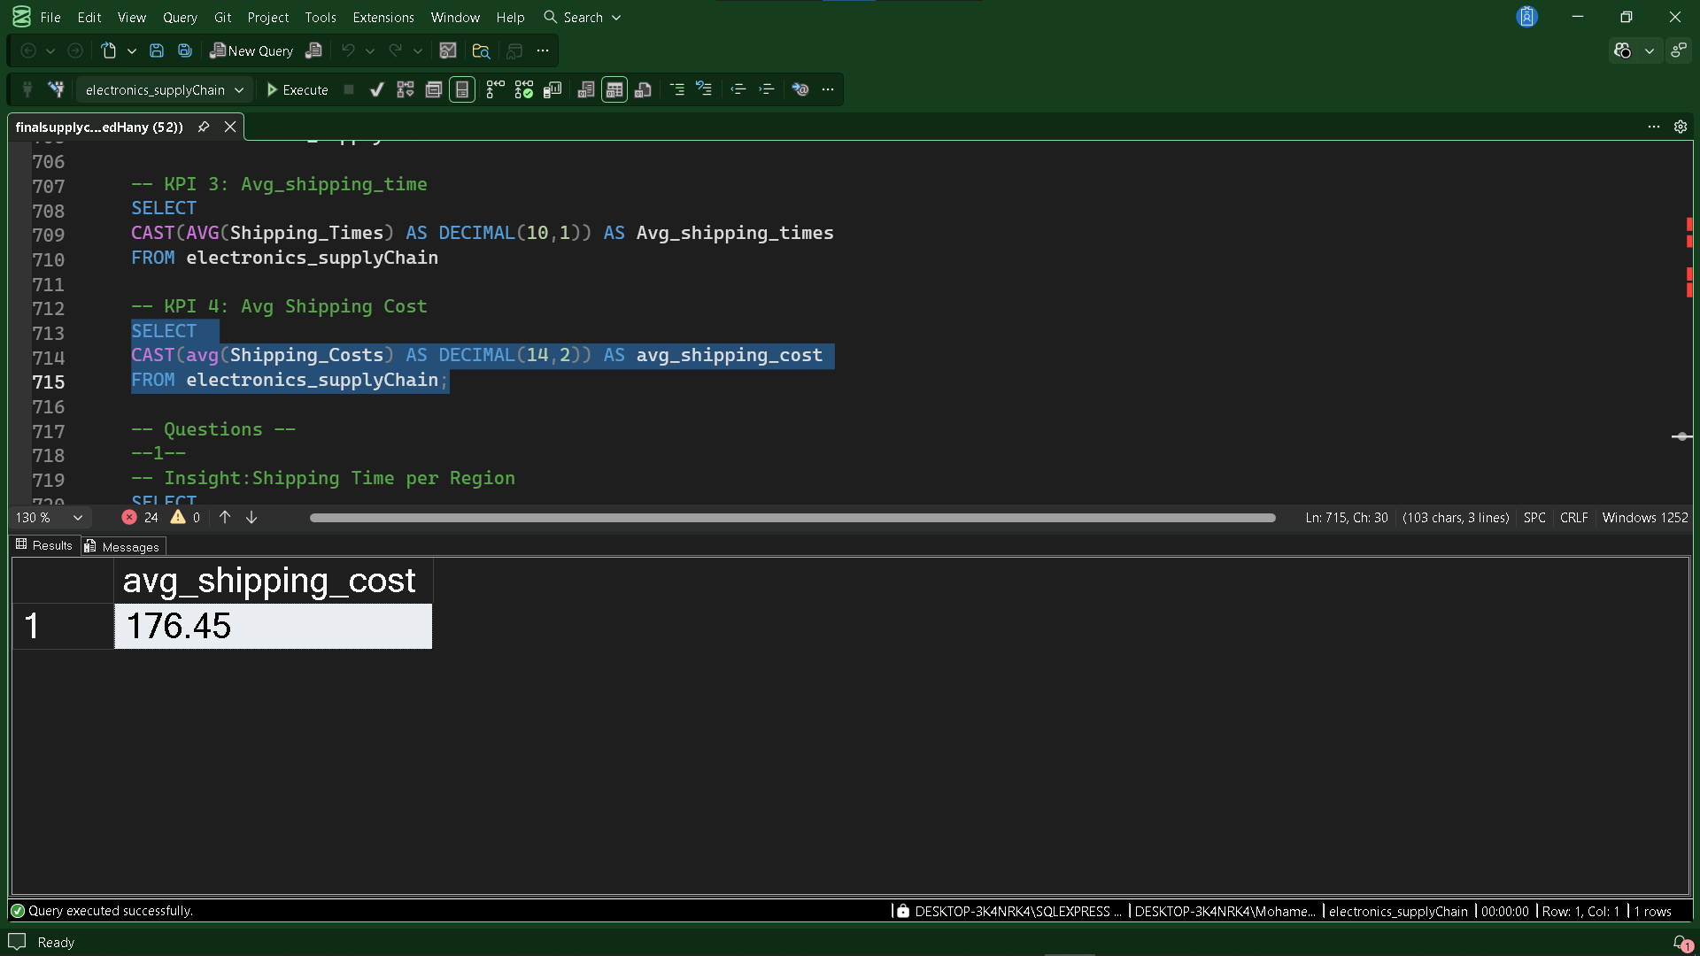
The analysis shows that the average shipping cost per shipment is $176.45, representing the typical transportation cost for delivering an order.

12.6 Shipping Cost & Units Sold by Region
Shipping cost and total units sold were analyzed across regions to compare logistics expenses with sales distribution.
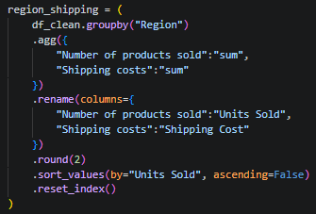
Excel
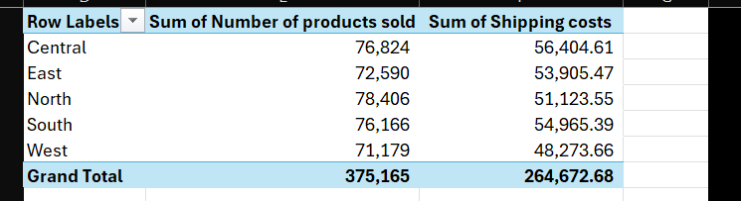
SQL Validation
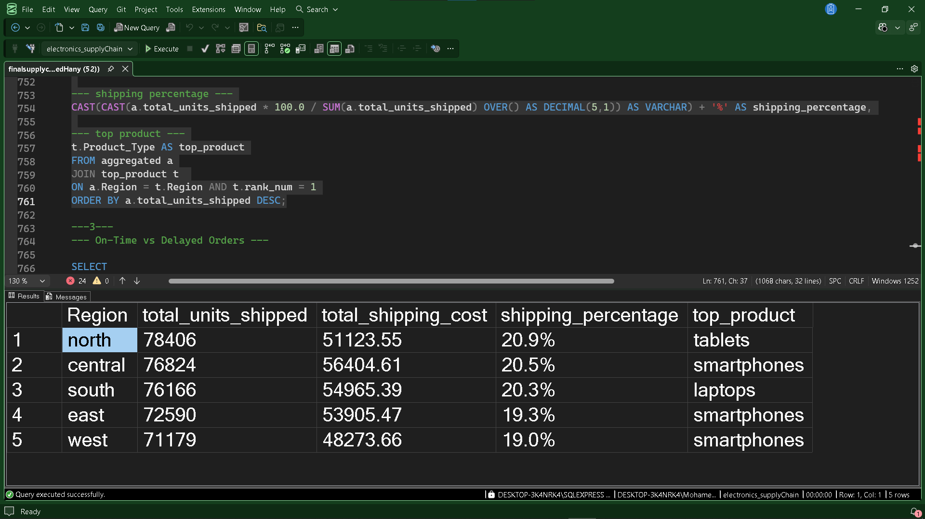
The analysis shows that the North region recorded the highest sales volume (78,406 units), while the Central region incurred the highest shipping cost ($56,404.61). The West region had both the lowest shipping cost ($48,273.66) and the lowest number of units sold (71,179).
12.7 Shipping Cost & Units Sold by Product Type
Shipping cost and total units sold were analyzed across product types to evaluate logistics expenses relative to product sales.
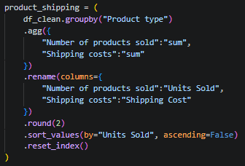
Excel
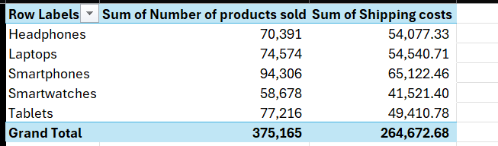
SQL Validation
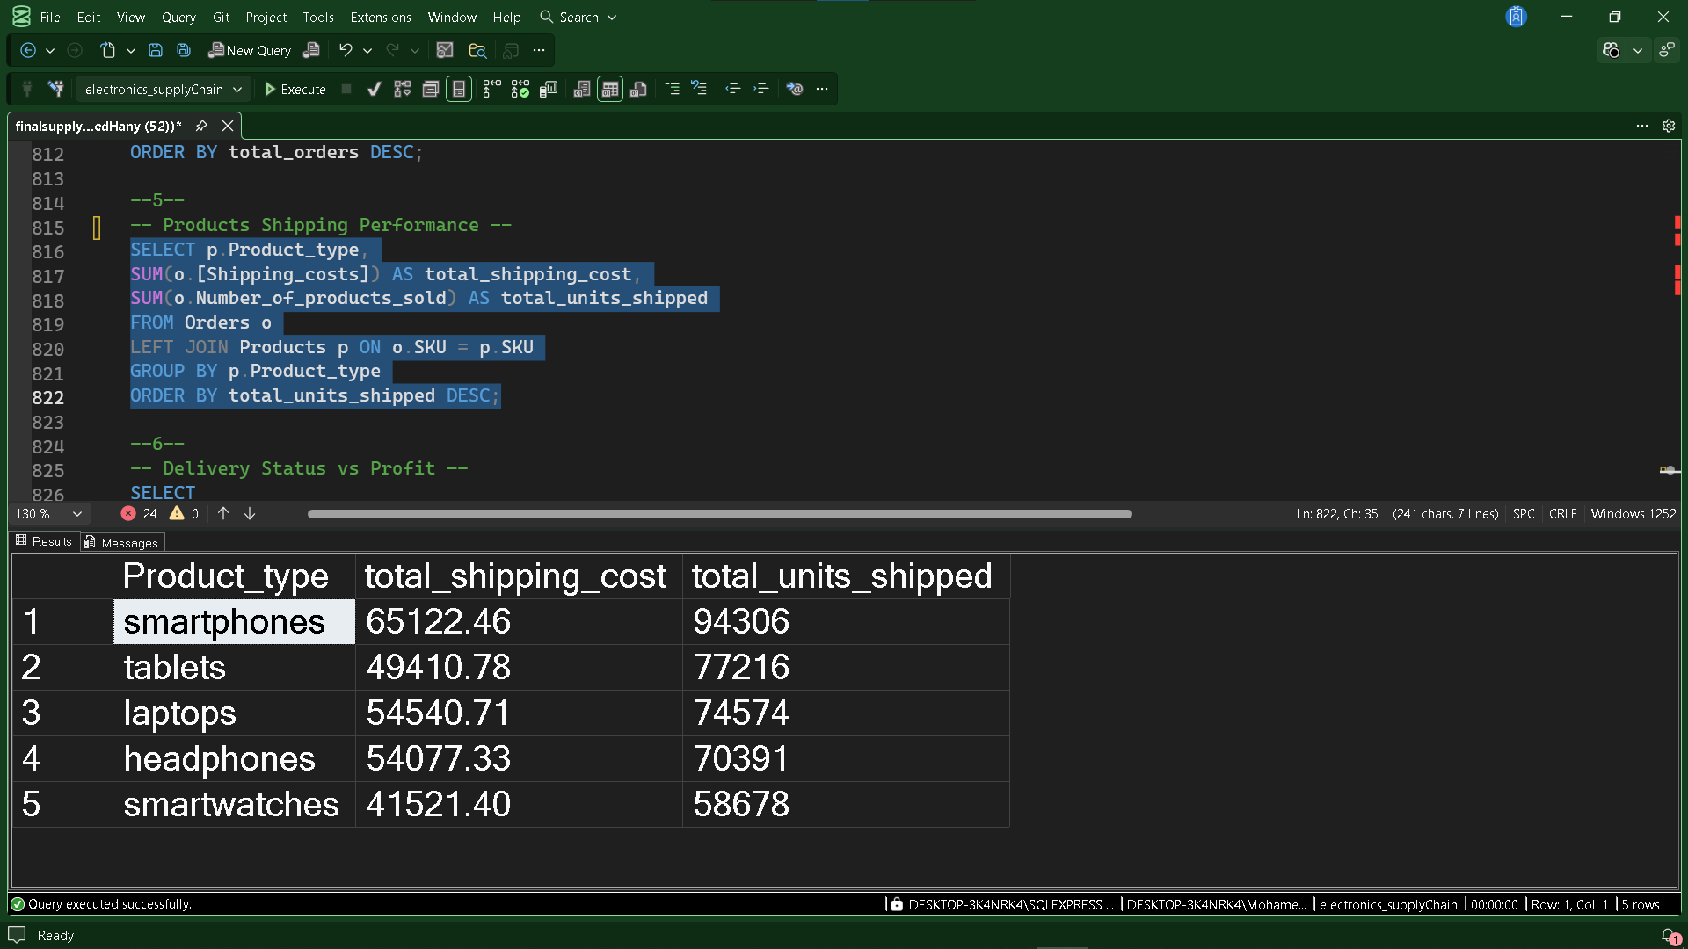
The analysis shows that Smartphones generated the highest sales volume (94,306 units) and also incurred the highest shipping cost ($65,122.46). In contrast, Smartwatches recorded both the lowest units sold (58,678) and the lowest shipping cost ($41,521.40).

12.8 Best Delivery Performance by Region
Delivery performance was analyzed by comparing the number of on-time and delayed orders across different regions.
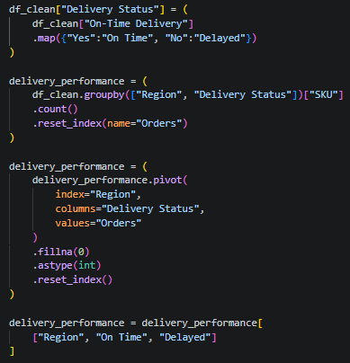
Excel
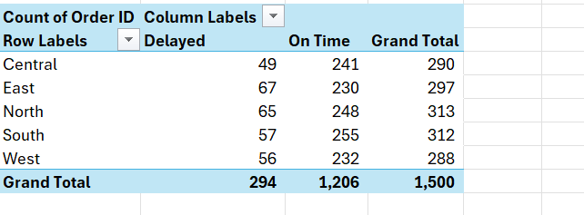

SQL Validation
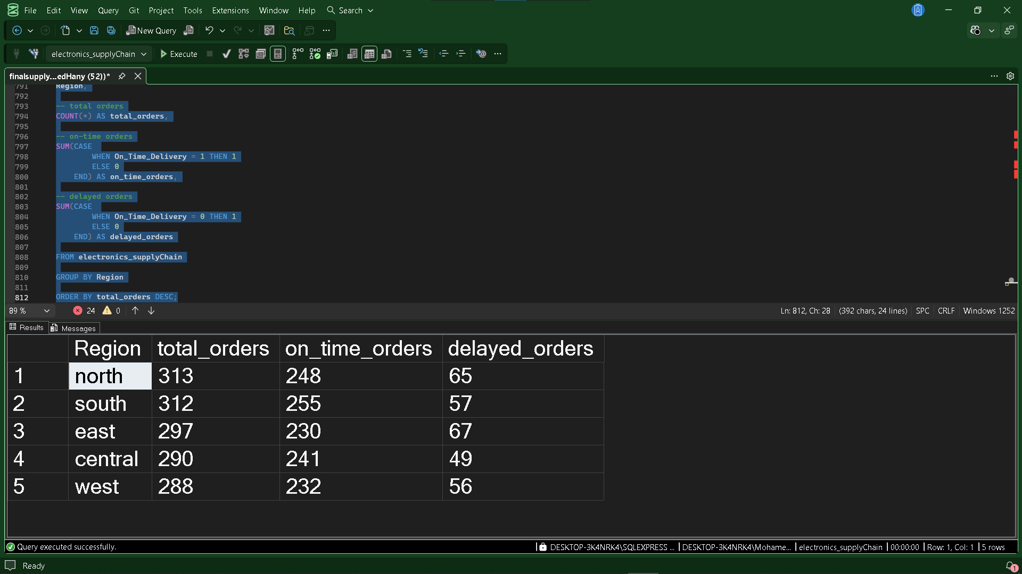
The analysis shows that the South region achieved the highest number of on-time deliveries (255 orders), while the Central region recorded the fewest delayed deliveries (49 orders). In contrast, the East region had the highest number of delayed orders (67), indicating relatively weaker delivery performance.
12.9 On-Time vs Delayed Orders
Orders were classified based on their delivery status to evaluate the percentage of shipments delivered on time versus delayed.
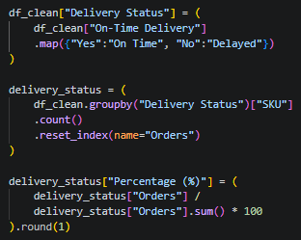

Excel
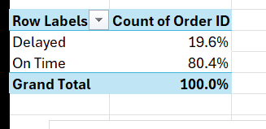
SQL Validation
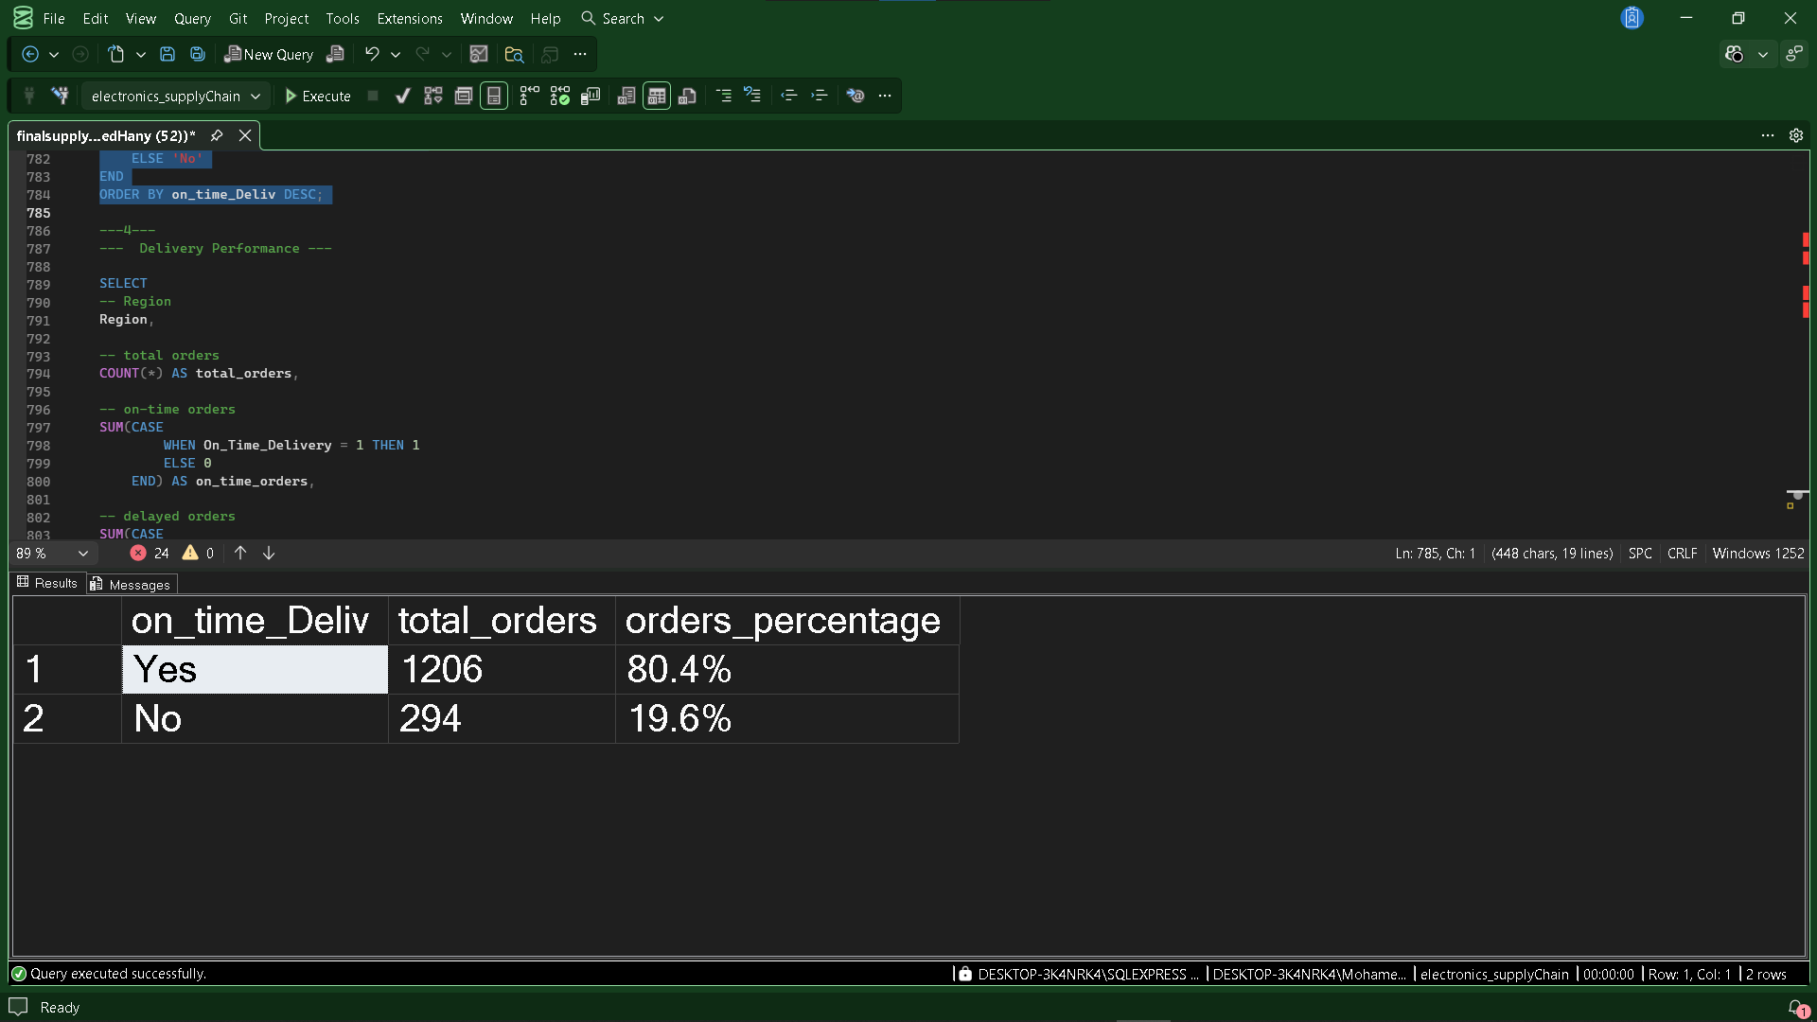

The analysis shows that 80.4% of orders were delivered On Time, while 19.6% were Delayed, indicating a strong overall delivery performance.

12.9 Average Shipping Duration by Region
The average shipping duration was analyzed across regions to compare delivery speed and identify regional differences in shipping performance.
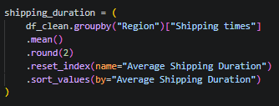
Excel 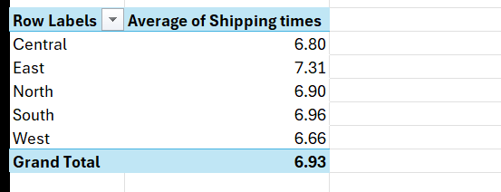
SQL Validation
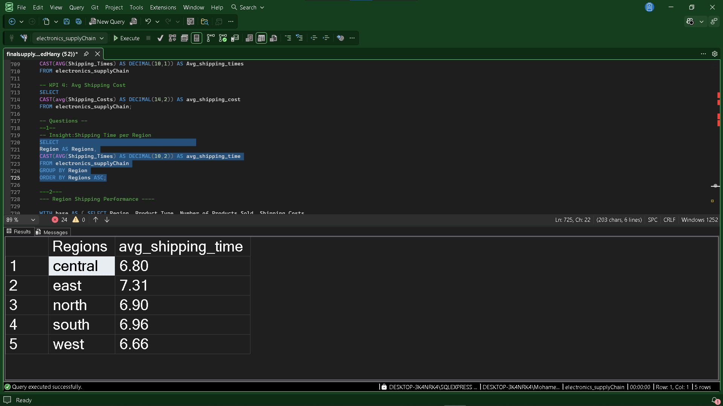

The analysis shows that the West region has the shortest average shipping duration (6.66 days), while the East region has the longest average shipping duration (7.31 days). This indicates that deliveries are completed faster in the West compared to the other regions.
12.10 Profit by Delivery Status
Profit was analyzed based on delivery status to evaluate the financial impact of on-time and delayed deliveries.
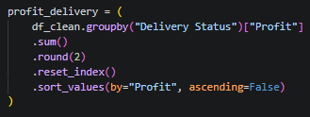
Excel
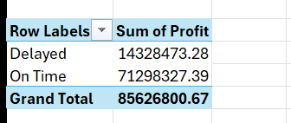

The analysis shows that On-Time deliveries generated $71.30M in profit, significantly outperforming Delayed deliveries, which generated $14.33M. This highlights the positive financial impact of maintaining high on-time delivery performance.

12.11 Domain Summary
The Shipping Analytics analysis evaluated logistics performance by measuring shipping costs, lead times, delivery times, regional shipping efficiency, and delivery status. It also assessed how shipping operations affect sales distribution and overall profitability.
Overall, the analysis provides valuable insights into transportation efficiency, regional delivery performance, and the relationship between logistics operations and business profitability.

Key Insights
- The total shipping cost reached $264,672.68, with an average shipping cost of $176.45 per shipment.
- The average lead time is 13.49 days, while the average shipping time is 6.93 days.
- The North region recorded the highest sales volume (78,406 units), whereas the Central region incurred the highest shipping cost ($56,404.61).
- Smartphones generated the highest units sold (94,306) and the highest shipping cost ($65,122.46).
- The South region achieved the highest number of on-time deliveries (255), while the East region recorded the highest number of delayed deliveries (67).
- Overall, 80.4% of orders were delivered on time, compared to 19.6% delayed orders.
- The West region recorded the shortest average shipping duration (6.66 days), indicating the fastest delivery performance.
- On-time deliveries generated approximately $71.30M in profit, significantly higher than the $14.33M generated by delayed deliveries.

Business Value
This analysis helps evaluate logistics performance by measuring shipping efficiency, transportation costs, and delivery reliability across regions and product categories. The insights support better logistics planning, delivery optimization, cost control, and customer satisfaction, while emphasizing the financial importance of maintaining high on-time delivery performance.

13. Overall Project Summary
This project analyzed the Electronic Supply Chain dataset using Python for data analysis and Tableau for interactive dashboard visualization. The analysis covered five business domains: Sales Performance, Customer Experience & Returns, Supplier Performance, Inventory Management, and Shipping Analytics. Each domain answered key business questions and provided actionable insights through data-driven analysis.

14. Overall Key Findings
- Total Revenue exceeded $182.8M, with an overall profit margin of 46.84%.
- Customer return rate remained relatively low at 7.38%, while over 80% of deliveries were completed on time.
- Supplier performance showed an average quality score of 50.23 and an average reliability score of 65.30%.
- More than 55% of SKUs were classified as stockout risk, highlighting inventory planning opportunities.
- Smartphones consistently generated the highest revenue, sales volume, and production volume across multiple business domains.
- Shipping performance remained efficient, with an average shipping time of 6.93 days and strong profitability from on-time deliveries.

16 Recommendations
16.1 Short-Run Recommendations
- discounting strategy by restricting high discount offerings (10%-15% band) to protect net profit margins, shifting focus toward the low-to-medium bracket (0%-10%) to drive optimal profitability.

- low-performing SKUs by tracking the bottom 5 SKUs by units sold to freeze or eliminate slow-moving stock and effectively reduce holding costs.

- supplier sourcing by increasing procurement shares with Supplier 4 due to their leading Value Score (7.039), while gradually reducing reliance on Supplier 2 due to disproportionately high manufacturing costs.

- strict quality control-particularly for Supplier 5-to curb a 2.1% increase in defect rates, despite an overall 21.19% improvement in supplier reliability.

- customer satisfaction by pushing the stagnating CSAT score (3.28) upward through addressing product defects, which data proves is the primary driver of dissatisfaction.

- revenue by minimizing the current 19.6% delivery delay rate, securing higher profitability from on-time fulfillment ($71.3M) compared to delayed shipments ($14.3M).Long-Run Recommendations (Strategic Initiatives)

  - Long-Run Recommendations
- on high-margin channels by scaling up operations and marketing for the Online channel to leverage its superior commercial profitability of $18.27M.

- regional sales balance by maintaining the current distribution equilibrium across all five
regions, supporting a stable profit margin performance between 45% and 48%.

- return management by developing a structured process to reduce return losses and recover product value efficiently through better inspection, refurbishing, and remarketing.

- in "Star" products by increasing production support for Smartphones and Headphones to combine peak sales volumes with top-tier profit margins above 47%.

- East Region logistics by restructuring the delivery network or signing new courier contract to resolve high delay rates (67 delayed orders) and long shipping times (7.31 days).

17. Conclusion
This project demonstrates how data analytics can transform raw operational data into meaningful business insights. By combining Python for data preparation and business analysis with Tableau for interactive visualization, the project provides a comprehensive view of supply chain performance. The findings can support strategic decisions related to sales, inventory, suppliers, customer satisfaction, and logistics, ultimately improving operational efficiency and business performance.

